Enzyme Kinetics of Cellobiase, a Biocatalyst used in the Biofuel Industry

Emily Boggs

ABSTRACT: Cellobiase is an enzyme capable of catalyzing the breakdown of cellulose, and is being used to separate glucose resides for their transformation into biofuel. This experiment investigates the enzyme kinetics of cellobiase under different reaction conditions, including enzyme presence, temperature, pH, enzyme concentration, and initial substrate concentration. The reaction rate is monitored by the production of the yellow-colored molecule *p*-nitrophenol; the concentration of product produced by the enzyme can then be determined using spectroscopy. For the final condition, initial substrate concentration, a Michaelis-Menten plot was constructed using the initial reaction rates gathered from the spectroscopy data. The subsequent construction of a Lineweaver-Burk plot allowed the maximum rate and Km of cellobiase to be found.

**INTRODUCTION**

Cellulose (Fig. 1), a structural polymer the makes up the walls of plant cells, is the most common carbohydrate on earth [1]. Its β-1,4-glycosidic linkages between glucose residues allow the molecule to form extremely straight and long chains. Animals, including humans, lack the ability to properly digest cellulose. However, some animals that encounter large amounts of cellulose in their diet – like ruminants (sheep, cows) or wood-fiber eating insects (termites) – contain symbiotic microorganisms in their digestive tracts that can produce cellulose enzymes [2].

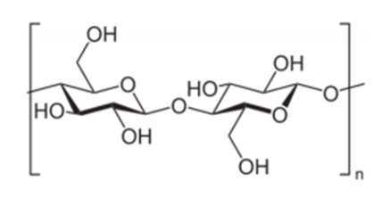

Figure 1: Molecular structure of cellulose.

Just because we can’t eat it doesn’t mean that humans haven’t found a myriad of uses for cellulose: cotton fibers are almost pure cellulose, and of course the wood we use for buildings and furniture is made from cellulose. Cellulose compounds were also used during the first half of the twentieth century as motion picture film base [3]. A new use has been found for cellulose, though, as fuel. The enzymatic breakdown of cellulose yields D-glucose molecules which can then be converted into ethanol via fermentation (Fig. 2). One enzyme used for this procedure is called cellobiase.

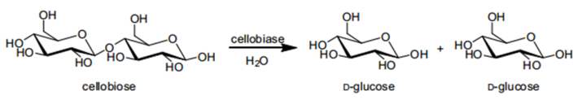

Figure 2: The breakdown of cellulose into glucose residues by cellobiase.

This experiment is investigating the kinetics of cellobiase. Cellobiase works to break the glycosidic bonds between glucose residues. However, since investigating the rate of catalysis requires a method to monitor the production of the product, the cellobiase will be breaking apart a dimer consisting of a single glucose residue and a molecule called *p*-nitrophenol (Fig 3). In basic conditions, *p-*nitrophenol reflects yellow light; the more *p*-nitrophenol present, the more intense the yellow color. This intensity can be quantified using spectroscopy and correlated to *p*-nitrophenol concentration through the use of a standard curve. Thus, the concentration of catalyzed product can be determined. The catalysis rate of the cellobiase enzyme will be observed under different conditions, including presence of enzyme, temperature, pH, enzyme concentration, and initial substrate concentration.

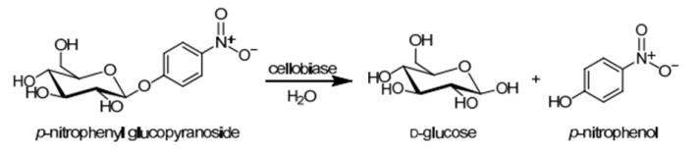



Figure 3: The breakdown of *p*-nitrophenol glucopyranoside into a glucose molecule and *p*-nitrophenol. The latter is yellow-colored in basic conditions.

**EXPERIMENTAL PROCEDURE**

The experiment was divided into five discreet analyses that monitored the reaction rate of cellobiase under different conditions. The reactions were allowed to proceed, with samples taken out at different time intervals and placed in stop solution, which stopped the catalysis and provided a “snapshot” of the reaction at that point in time. In addition, the stop solution contained a strong base, changing the color of any *p*-nitrophenol in the solution to yellow. After reaction samples were procured, they were analyzed for *p*-nitrophenol concentration in the spectrophotometer. A standard curve of the absorbencies of known concentrations of *p*-nitrophenol was computed. This curve was used in all activities to convert between absorbency and concentration.

Activity 1 tested whether the presence of cellobiase altered the rate of substrate breakdown. Cellobiase was added to a solution of the substrate, and samples were removed and placed in stop solution at 1, 2, 4, 6, and 8 minute time points after the reaction began. In addition, a sample containing just the substrate solution was used as a control, with a sample placed in stop solution after 8 minutes.

Activity 2 tested the rate of catalysis at three different temperatures: 0, 22 and 37 °C. Cellobiase and substrate were combined in tubes at these temperatures. The reaction at 0 °C was kept on ice, the reaction at 37 °C was kept in an incubator, and the reaction at 22 °C was kept in a rack on the benchtop. 2 minutes after the beginning of the reaction, samples were removed from each tube and placed in stop solution.

Activity 3 tested the effect of pH on the reaction rate. Three reactions were carried out in buffers at pHs of 5, 6.3, and 8.6. Reaction samples were placed in stop solution after 2 and a half minutes.

Activity 4 tested the effect of cellobiase concentration on reaction rate. Two concentrations, a high and a low, were used in two separate reactions. Each concentration had samples removed at 1, 2, and 8 minute intervals after the beginning of the reaction.

Activity 5 tested the effect of different initial substrate concentrations on reaction rate. Six concentrations were run in separate reactions. Samples were removed and placed in stop solution at 1, 2, and 8 minutes after the reaction began for each concentration.

**RESULTS AND DISSCUSION**

**Activity 1:** The concentration of product produced in the enzyme-catalyzed reaction was 1.804 nmol, while the product concentration in the uncatalyzed reaction was 0.015 nmol. It is also worth noting that the beginning measured concentration was 0.014 nmol. The amount of product produced in the catalyzed reaction was approximately 120 times greater than the final product concentration in the uncatalyzed reaction.

Although the curve produced by the eight minute reaction appears linear, data from the same reaction over a longer period of time will eventually approach an asymptote corresponding to the decrease in concentration of the substrate. This being said, it is unwise to extrapolate the reaction rate from 8 to 15 minutes given the current, linear data. It may be possible that by 15 minutes after the reaction start, the substrate had been all used up, providing a reaction rate lower than that at the eight minute mark.

**Activity 2:** From the data, this enzyme demonstrates the fastest reaction rate at 37 °C. Since 37 °C was the highest temperature tested, it is unknown if this temperature is in cellobiase’s optimal range or if temperatures higher than 37 °C will produce a faster reaction rate.

Since cellulose cannot be digested by animals on their own, this enzyme is likely secreted by single celled organisms (like bacteria and/or protozoa) and/or fungi. Given that cellobiase appears to work best in at least 37 °C, this enzyme is probably produced by bacteria that live in the digestive tracts of warm-blooded ruminating animals like cows.

**Activity 3:** The cellobiase-catalyzed reaction demonstrated the greatest rate at a pH of 5; again, given that this pH was on an extreme end of parameters tested (like 37 °C being the highest temperature tested), it is still not clear if a pH of 5 is the optimal pH for cellobiase catalysis, or if a lower pH is even better.

Most enzymatic reactions slow down or stop completely in pH conditions outside of around 7. This is because a shift up or down the pH scale can protonate or deprotonate amino acids and thus interfere with their ability to create hydrogen bonds with other amino acids. Since these hydrogen bonds give rise to the tertiary structure of proteins, proteins in extreme pH conditions will likely denature into a primary amino acid chain. Since the catalysis abilities of enzymes are completely dependent on the molecule’s tertiary structure, a denatured enzyme will not work.

**Activity 4:** The reaction rate of the reaction containing a high concentration of enzymes was much greater that the rate of the low-concentration enzyme reaction. The V¬o for the high-concentration reaction was 38.031 nmol/min, almost three times the rate of the low-concentration reaction rate at 13.886 nmol/min. The increase reaction rate for the high-concentration reaction was simply because that reaction, by having more enzymes, had more active sites for catalysis to take place.

However, the concentration of the enzyme will not have an effect on the final concentration of product; both reactions, if given enough time, will end with the same amounts of product. The higher-concentration reaction just increased the speed at which all the substrate molecules were catalyzed. Thus, it can produce the same amount of product, but sooner.

C:\Users\eboggs\AppData\Local\Microsoft\Windows\Temporary Internet Files\Content.IE5\5UW7G1V1\MC900391216[1].wmf**Activity 5:** Overall, the trend appears to be that an increase in initial substrate concentration produces a higher initial reaction rate. However, while initial rate may be increased, the rest of the reaction rate may not be sustained, as was the case with the rate of sample 4 (1 mM substrate) eventually dipping below the rate of the lower concentration sample 3(0.67 mM substrate). This likely just has to do purely with kinetics; the increase in substrate molecules will increase the probability that a reaction is being catalyzed. The final absorbencies taken at 8 minutes for S5 and S6 were at levels higher than the highest value given on the standard curve (2.02 and 2.174, respectively, against 1.889). However, since these two values were not higher than the curve by a significant amount, the absorbencies were kept in the calculation.

To fill in this ugly blank space, here is a picture of a flower that probably has cellulose in it.

The final concentrations of each substrate concentration were as follows: S1 at 32.798 nmol; S2 at 49.534 nmol; S3 at 82.850 nmol; S4 at 77.150 nmol; S5 at 105.34 nmol; S6 at 113.32 nmol,

The Km and Vmax values values from the Michaelis-Menten plot can only be estimated. Since the Vmax value cannot be explicitly derived from this graph, an educated guess must be made as to at what rate the reaction will reach before it levels off. I estimate, from the plot that the value of Vmax is approximately 26 nmol/min. This would make the V1/2max value around 13 nmol/min; the corresponding concentration (x-value) at 13 is around 0.6 nmol, which is the Km value.

The actual values of Vmax and K¬m can be computed directly by using the inverse of the Michaelis-Menten plot, creating a Lineweaver-Burk plot. The y-intercept of this plot is 1/Vmax and the x-intercept is -1/Km. Analysis of this plot yields 28.818 nmol/min as the Vmax and 0.54765 nmol for Km. Since the values from the Lineweaver-Burk plot were directly calculated from the experimental data and just estimated from the Michaelis-Menten plot, the values given by the former are likely to be more accurate.

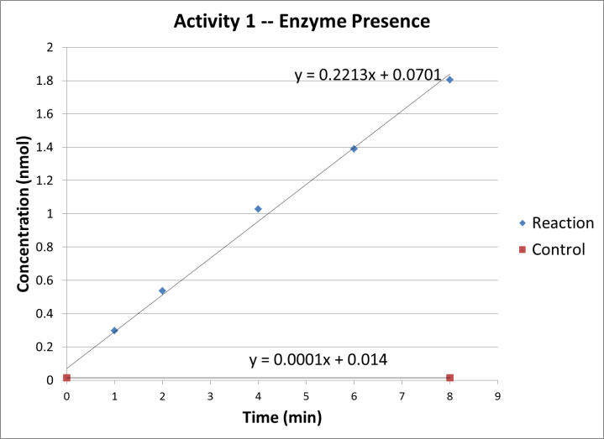

Figure 4: Concentration vs. Time for activity 1 (enzyme presence).

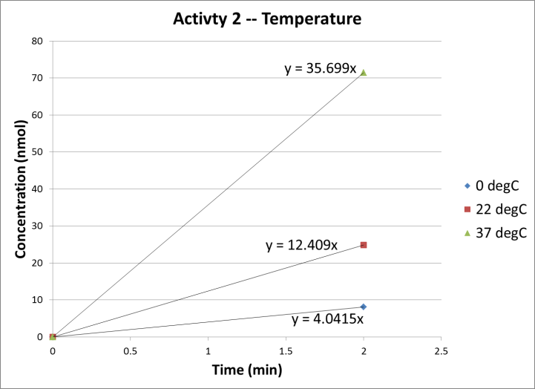

Figure 5: Concentration vs. Time for activity 2 (temperature).

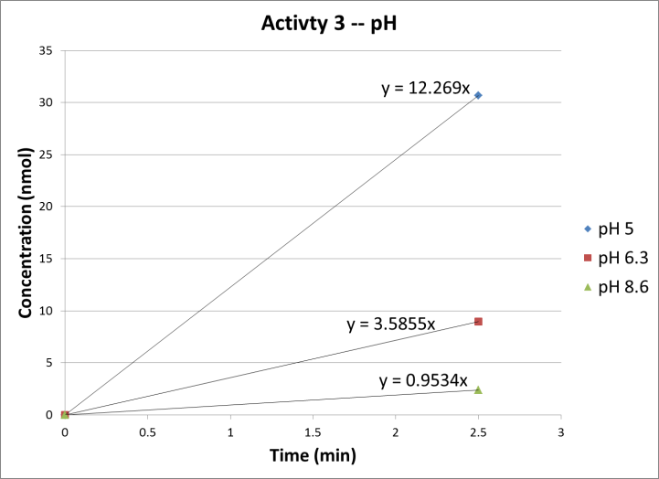

Figure 6: Concentration vs. Time for activity 3 (pH).

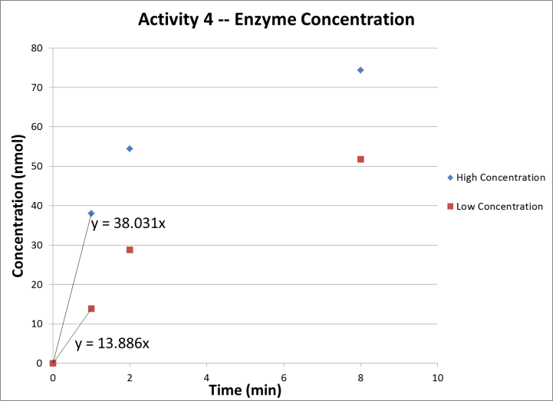

Figure 7: Concentration vs. Time for activity 4 (enzyme concentration).

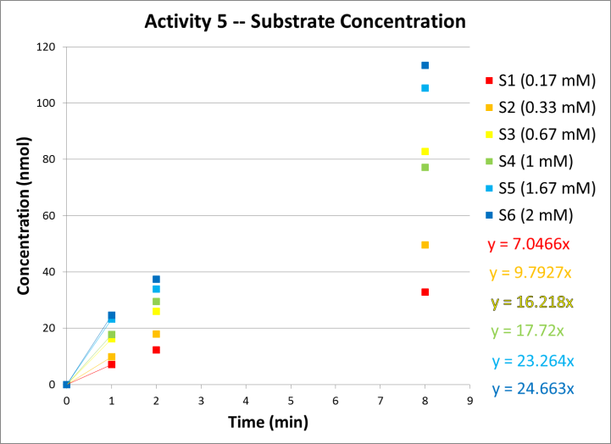

Figure 8: Concentration vs. Time for activity 5 (initial substrate concentration).

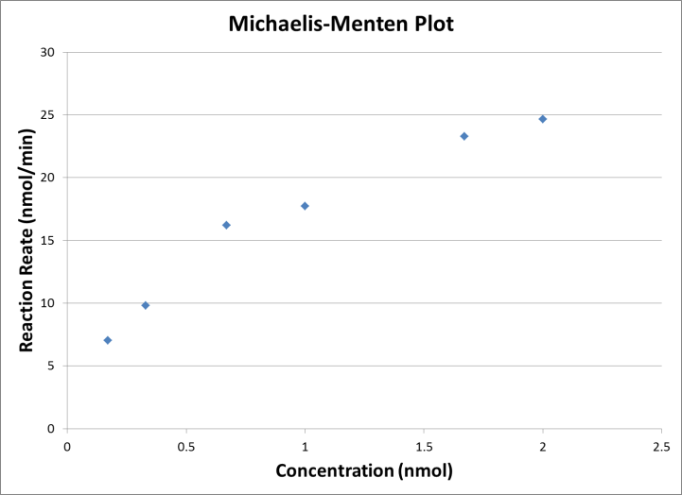

Figure 9: Michaelis-Menten plot constructed using the initial reaction rates (Vo) for each reaction in activity 5 vs. concentration.

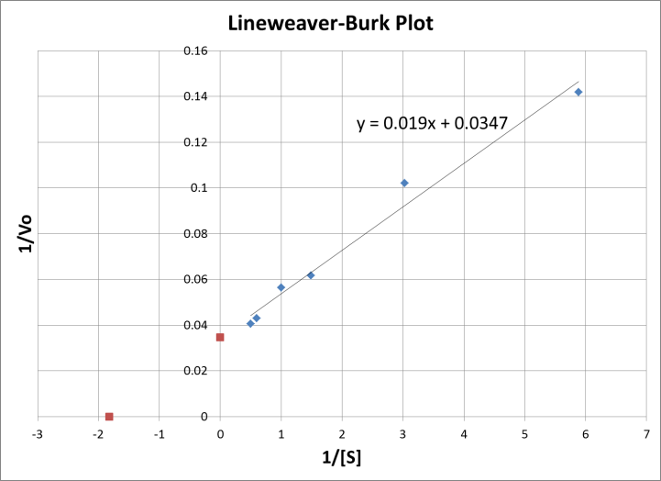

Figure 10: A Lineweaver-Burk plot constructed with data obtained from the Michaelis-Menten plot; 1/Vo vs. 1/concentration. The points on the graph at 1/Vmax and -1/Km have been added and are in red.

**Final Remarks:** A small amount of research [4] confirms that cellobiase is indeed an enzyme produced by bacteria and protozoans in the digestive tracts of ruminants (I did not expect my guess to be that accurate, actually). This explains why they perform so well at high temperatures found in warm-blooded mammals that cannot digest cellulose on their own. It also explains why the enzyme seems to work optimally at a low pH, given that it will be working in acidic material from the stomach.

Perhaps for subsequent versions of this lab a temperature higher than 37 °C and a pH lower than 5 can also be tested, to drive home the fact that this enzyme works best in those conditions.

ACKNOWLEDGEMENTS

I want to express many thanks to my lab partner Jaime Willbur for helping me slog through the extremely high-maintenance and timed kinetic procedures, even though we were both sick. I’d also like to thank Dr. Timmons for providing the large amount of materials required for this project, and just being on top of everything in general. Much thanks also to Lawrence Tech.

REFERENCES

1. Timmons, S. C. (2012). Experiment 4: Enzyme Kinetics of Cellobiase, a Biocatalyst used in the Biofuel Industry, p. 4-7
2. Cellulose. <http://www.elmhurst.edu/~chm/vchembook/547cellulose.html>. Accessed November 12, 2012.
3. Timeline for film history. <http://www.brightlineinteractive.com/_projects/NPS-CS/flash/pdf/2.3.1a.pdf>. Accessed November 14, 2012.
4. Cellobiase. http://medical-dictionary.thefreedictionary.com/cellobiase. Accessed November 15. 2012.