Emily Boggs
Mesenchymal stem cells mechanically stimulated in vitro may provide enhanced healing in vivo
Osteoarthritis, a debilitating but very common disorder, represents a set of conditions caused by the loss of cartilage and/or subchondral bone in a joint. The eventual formation of osteoarthritis in individuals is mostly due to extended wear and tear of cartilage as well as its intrinsic inability to fully heal. As an avascular tissue [1], cartilage has virtually no method for bringing in nutrients from the bloodstream to replenish damaged areas. While the damage of cartilaginous tissue can cause an immediate local response – a promising cacophony of chondrocyte proliferation and matrix synthesis – the response is too short-lived to make a substantial impact in healing the defect [2].
One strategy to combat cartilage degeneration, autologous chondrocyte transplantation, gained popularity in clinical trials during the late 90s. This method involves the harvest of chondrocytes from the subject’s own tissue, multiplying their numbers in vitro, and injecting them into the site of the cartilaginous defect [2]. However, this method was often hindered by the fact that chondrocytes comprise only 5-10% of cartilage tissue, requiring the excision of large areas of cartilage for a substantial number of chondrocytes to be harvested. In addition, the in vitro culture of chondrocytes causes them to slowly lose their genotypic characteristics in a process called “dedifferentiation.” This development is marked by a decrease in the synthesis of collagen II and proteoglycans [3].
Another approach to the regeneration of cartilage is the injection of mesenchymal stem cells (MSCs) into the defect area. MSCs are adult stem cells found in bone marrow. Though not as varied in their differentiation abilities as embryonic stem cells, MSCs can mature into bone, cartilage, muscle, adipose, ligament, tendon, and stroma lineages [4], making them potent regenerative tools for these tissues. Researched applications of regenerative MSC injections include cardiovascular repair, treatment of lung ﬁbrosis, intervertebral disc regeneration and bone and cartilage repair. Research into the differentiation of MSCs has generated “recipes” of the different culture conditions and mechanical stimuli needed to induce a specific lineage [5].
However, the specter of carcinogenesis has been a constant companion following stem cell regeneration research. There is a fear that stems cells, including MSCs, when injected into the body will remain undifferentiated clumps and form a tumor. While no exact cases of this happening with MSCs have been reported, Karnoub et al. [6] found that MSCs can be recruited by malignant breast cancer cells to form a supportive stroma layer. In addition, these newly incorporated cells release a chemokine that increases cancer cell motility and thus encourages metastasis. However, fully differentiated MSCs do not display this behavior.
This concern can be nullified, however, by utilizing only MSCs that have already differentiated in these injections. Since MSCs have an incredible potential for unlimited in vitro replication [7] they could be used for autologous chondrocyte transplantation by first providing a large number of cells. Then, the MSCs could subsequently be differentiated into chondrocytes before implantation.
A proven “recipe” for MSC differentiation into the chondrocytic lineage is coculturing with the cytokine transforming growth factor beta-1 (TGF-β1) [7]. In addition, cyclic compressive loading has been proven to induce chondrogenic differentiation in MSCs, as it most naturally mimics the forces undergone by chondrocytes and stem cells in vivo [8], [9] over other types of mechanical stimulation. Huang et al. [11] demonstrated that MSCs cultured with both TGF-β1 and compressive mechanical stimulation showed a greater expression of collagen II and aggrecan over cultures differentiated with just one of the methods.
The goal of this procedure is to determine the regenerative effect when chondrocyte-differentiated MSCs are injected into the site of a cartilage defect. The factors used to induce differentiation will include both chemical and mechanical stimulation.

MATERIALS
Bioreactor
A bioreactor (Fig. 1) capable of applying cyclic compressive loading is required. The design itself is simple and needs to be little more than a modified cell culture plate. The compressive force will be provided by a piston. The cells themselves will be cultured in small round wells. Pressure will be applied to the cells from the piston through cylindrical 2% weight agarose gels. The cylindrical gels themselves will be projections from a sheet of the same material, which serves as a plane of connection between the cylinders and the piston.

Figure 1: Novel design for a compressive loading bioreactor.
The use of 2% weight agarose gel for compressive stimulation comes as the optimized material from a study by Waldman et al. [10]. The piston will compress with a sinusoidal loading pattern at 1 Hz at 10% strain. The compression cycles will occur during a single four hour block every day for 14 days [11].

Animal Models
New Zealand white rabbits from the animal model supplier Charles River will be used for this procedure. The species and breed were chosen as ideal based on the following criteria.
Rabbits are often chosen as models for cartilage regeneration-based studies; New Zealand white rabbits, in particular, have a layer of cartilage thicker than any other breed of rabbit, making it ideal for studies in which osteoarthritis must be induced. In addition, rabbits can also come in genotypically similar groups, a boon to reducing the overall variability of the experiment. Furthermore, rabbits are small, easy to care for, and represent a relatively inexpensive animal model, allowing for their testing in high numbers [12]. The rabbits will be from of 6 months to 1 year in age. The number of rabbits to be used in this study will be determined by power analysis to provide for statistical significance.
The rabbits will be kept in open enclosures with approximately 0.45m² per rabbit. The floor will be made of sealed vinyl over a concrete floor for easy cleaning but with a several-inch layer of sawdust to prevent rabbit injury (i.e. sore hocks) and encourage natural behaviors like digging, shredding, and foraging. Structural elements in the pens will include slightly raised shelf-like areas approximately 6 inches above the floor in certain areas of the pen. In addition to the space under these shelves, refuges (small box-like containers open on one or both sides) will be provided. These additions are designed to reflect rabbit behavior, including using height to scan the environment and having secluded places to hide when stressed. Several smaller pens for individual rabbits will be kept to one side, sharing a cage wall with the main pen. These enclosures will be where rabbits returning from surgery will stay for several hours. The purpose of sharing an open cage wall between the pens is so that the recovering rabbit is not isolated from the rest of the group and still experiences the same visual, auditory, and olfactory stimulations as before. Post-operative rabbits will not be immobilized in any way, as this could affect healing results. The rabbits will be fed a diet of mostly pellet food supplemented by hay, grass, and fruit [13].

Cells and culture
Rabbit MSCs will be obtained from the biological supply company Cyagen. Having obtained the cells from a source besides the animal models will mimic an allogeneic transplant. This is preferable for three reasons: first, the success of an allogeneic transplant will likely herald the success of an autologous transplant of the same nature. Next, the harvesting of cells from every test subject for autologous transplant would be time-consuming and complicated procedure. Lastly, the use of a commercial strain ensures that all the MSCs used in the procedure are the same, substantially reducing variability.
Transforming growth factor beta (TGF-β) for rabbit MSCs will be supplied from Epitomics. Ham’s F10 nutrient mixture for media, a media used especially for mammalian stem cell culture, will be supplied from SigmaAldrich. The stains hematoxylin and eosin will also be procured from SigmaAldrich; the stain safranin-O from Takara. The RNA primers for collagen II and aggrecan for use in RT-PCR will be supplied from Bioneer.

METHODS
MSC culture will begin 14 days before injection. All cells will be cultured in Ham’s F10 nutrient mixture, supplemented with 10% fetal bovine serum and the antibiotics penicillin and streptomycin. The cells will be kept in an incubator at 39 °C (normal rabbit body temperature) and 5% carbon dioxide. A concentration of 10 ng/mL of TGF-β1 will be maintained in culture [14]. Half of the cells will remain in static culture while the other half is subjected to 10% strain compressive sinusoidal loading at 1 Hz for four hours every day.
The total rabbit sample size n will be divided into three groups of size n/3:
- The control group – after induction of osteoarthritis, these models will receive only media injections.
- The growth factor-only group – after induction of osteoarthritis, these models will receive injections of chondrocytes differentiated from MSCs only by the use of the chemical growth factor TGF-β.
- The growth factor and mechanical stimulation group – after induction of osteoarthritis, these models will receive injections of chondrocytes differentiated from MSCs by both TGF-β and compressive loading.
Osteoarthritis will be induced by cutting a circular defect on the patellar groove with a diameter of 3 mm and a depth of 2 mm into the subchondral bone. Each subject will receive only one defect. The defect will be allowed to heal on its own for six weeks before injections are administered; the purpose of this wait period is to remove the variable of inflammatory and immune response that may interfere with the efficacy of treatment.
After the six weeks, the subjects will receive an injection of 10⁶ chondrocytes in 0.025 mL of Ham’s F10 nutrient mixture (except the control group which will receive only the media). The animals will be sacrificed via barbiturate injection at the 14 week mark after injections. For each subject, the distal/femoral knee area will be resectioned for analysis.
Histological analysis will include staining samples with hematoxylin, eosin, and safranin-O. The stains hematoxylin and eosin (or an H&E stain) are commonly used in histology to highlight cell nuclei and extracellular protein. Safranin-O will be applied as it stains proteoglycans [15]. Thus, the H&E stain will allow for an estimate to be made in the numbers of active cells in the cartilage, while the safranin-O stain will assess the extent of cartilage-specific extracellular matrix formation.
In addition to histology, samples will also undergo RT-PCR to determine the relative amounts of collagen II and aggrecan synthesis taking place.

EXPECTED RESULTS
After 14 weeks, the borders of the original defect should still be visible upon gross examination, though regeneration of the subchondral bone and cartilage should be apparent. The regenerated cartilage in the experimental groups should take the appearance of the surrounding articular cartilage, while the control group should exhibit the fibrous scar tissue typical of self-healing cartilage [2].
Histological findings will be based on a scale (see appendix) developed by Im et al. [16]. Higher numbers indicate more fully healed cartilage. The scale takes into account not only the histology and morphology of the cartilage, but the structural elements of the healed defect and its interaction with the surrounding cartilage. Im et al., who studied the regeneration of in vivo rabbit cartilage after injections with undifferentiated MSCs, reported a mean score of 8.9 ± 4.7 for their control group. Since their control group underwent an osteoarthritis induction procedure very similar to the one described here, the score for this experiment’s control group will likely fall into the same range. There is no predetermined range for the experimental groups other than they should score higher than the control groups.
Visually, the differences in histology between experimental and control groups should be very noticeable. Note the images (Fig. 2) taken by Im et al.; the experimental group shows a large number of chondrocytes in the defect area (denoted by the open arrow) versus the surrounding cartilage (denoted by the black arrow). The control group, on the other hand, demonstrates a large fissure still present between the defect and surrounding cartilage, as well as a dearth of chondrocytes.
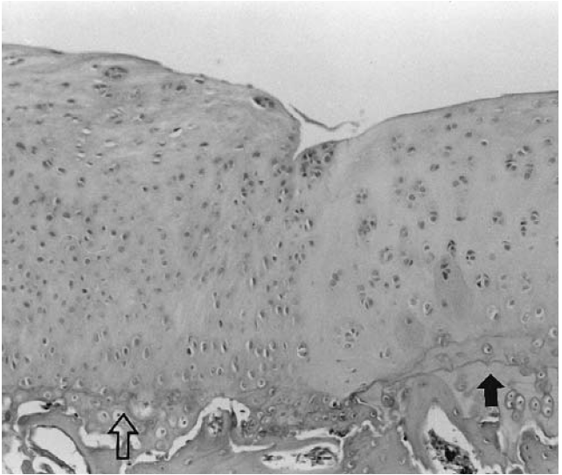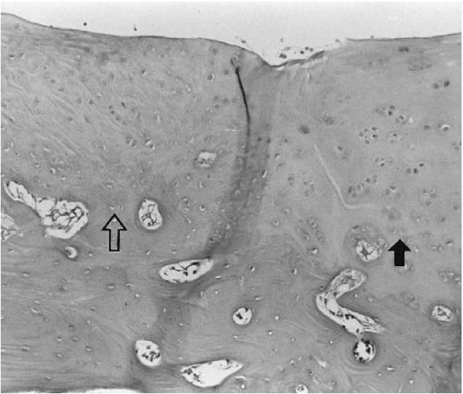
Figure 2: Histological analysis of a defect treated with MSC injection (left) versus the control (right) [16].

RT-PCR should show a large amount of the production of collagen II and aggrecan in the experimental tissue over samples from the control. In addition, as demonstrated by Huang et al. [11], the samples that received injections of chondrocytes that underwent mechanical stimulation in addition to growth factor culture should show higher amounts of collagen II and aggrecan being produced.

CHALLENGES
One challenge faced by this procedure is that the rabbit knee is not an accurate model of human physiology. However, if this research produces promising results, testing on a larger, more expensive model may commence. Goats [12] are also used as models in cartilage regeneration research, usually after evaluation trials with rabbits have been completed. Unlike rabbits, goats have a knee structure that is more closely related to that of humans.
Another challenge is the inclusion of a novel bioreactor. Since this bioreactor is not commercially available, other research groups may have a difficult time replicating this procedure without the exact same design.
Lastly, the behavior of the HSC-derived chondrocytes may be unpredictable. They may, for example, continue to grow irregular cartilage after the defect has healed. If a response like this should occur in a significant number of models, more research about the chemical signals that control cartilage growth may be needed.
References
*[1] "Histology Text Atlas Book." Visual Histology (Cytology) Teaching Series. Accessed 15 Dec. 2012. < http://www.visualhistology.com/products/atlas/VHA_Chpt5_Cartilage.html>
[2] S. N. Redman, S. F. Oldfield, and C. W, Archer. "Current Strategies for Articular Cartilage Repair." European Cells and Materials 9 (2005): 23-32.
[3] C. Chung, and J. A. Burdick. "Engineering Cartilage Tissue." Advanced Drug Delivery Reviews 60.2 (2008): 243-62.
[4] M. F. Pittenger, A. M. Mackey, S. C. Beck, R. K. Jaiswal, R. Douglas, J. D. Mosca, M. A. Moorman, D. W. Simonetti, S. Craig, and D. R. Marshak. "Multilineage Potential of Adult Human Mesenchymal Stem Cells." Science 284.5411 (1999): 143-47.
[5] F. P. Barry, and J. M. Murphy. "Mesenchymal Stem Cells: Clinical Applications and Biological Characterization." The International Journal of Biochemistry & Cell Biology 36.4 (2004): 568-84
[6] A. E. Karnoub, A. B. Dash, A. P. Vo, A. Sullivan, M. W. Brooks, G. W. Bell, A. L. Richardson, K. Polyak, R. Tubo, and R. A. Weinberg. "Mesenchymal Stem Cells within Tumour Stroma Promote Breast Cancer Metastasis." Nature 449.7162 (2007): 557-63.
[7] C. Guo, X. Liu, J. Huo, C. Jiang, X. Wen, and Z. Chen. "Novel Gene-modified-tissue Engineering of Cartilage Using Stable Transforming Growth Factor-β1-transfected Mesenchymal Stem Cells Grown on Chitosan Scaffolds." Journal of Bioscience and Bioengineering 103.6 (2007): 547-56.
[8] P. J. Prendergast, and P. E. McHugh. "Chapter IV: The State-of-the-Art in Cartilage Bioreactors." Topics in Bio-mechanical Engineering: Proceedings of the 1st Symposium on Biomechanical Engineering Held between the Trinity Centre for Bioengineering and the National Centre for Biomedical Engineering Science under the Programme for Research in Third Level Institutions. Dublin: TCBE, 2004. 94-146.
[9] A. H. Huang, M. J. Farrell, M. Kim, and R. L. Mauck. "Long-Term Dynamic Loading Improves the Mechanical Properties of Chondrogenic Mesenchymal Stem Cell-Laden Hydrogels." European Cells and Materials 19 (2010): 72-85.
[10] S. Waldman, D. Couto, M. Grynpas, R. Pilliar, and R. Kandel. "A Single Application of Cyclic Loading Can Accelerate Matrix Deposition and Enhance the Properties of Tissue-engineered Cartilage." Osteoarthritis and Cartilage 14.4 (2006): 323-30.
[11] C-Y. C. Huang, K. L. Hagar, L. E. Frost, Y. Sun, and H. S. Cheung. "Effects of Cyclic Compressive Loading on Chondrogenesis of Rabbit Bone-Marrow Derived Mesenchymal Stem Cells." Stem Cells 22.3 (2004): 313-23.
[12] C. R. Chu, M. Szczodry, and S. Bruno. "Animal Models for Cartilage Regeneration and Repair." Tissue Engineering Part B: Reviews 16.1 (2010): 105-15
*[13] Royal Society for the Prevention of Cruelty to Animals. Refining Rabbit Care. West Sussex: Royal Society for the Prevention of Cruelty to Animals, n.d.
[14] B. Schmitt, J. Ringe, T. Haupl, M. Notter, R. Manz, G. R. Burmester, M. Sittinger, and C. Kaps. "BMP2 Initiates Chondrogenic Lineage Development of Adult Human Mesenchymal Stem Cells in High-density Culture." Differentiation 71.9-10 (2003): 567-77.
[15] K. L. Camplejohn, and S. A. Allard. "Limitations of Safranin 'O' Staining in Proteoglycan-depleted Cartilage Demonstrated with Monoclonal Antibodies." Histochemistry89.15 (1988): 185-88.
[16] G. I. Im, D. Y. Kim, J. H. Shin, C. W. Hyun, and W. H. Cho. "Repair of Cartilage Defect in the Rabbit with Cultured Mesenchymal Stem Cells from Bone Marrow." The Journal of Bone and Joint Surgery 83-B.2 (2001): 289-94.

* Indicates that this source could not be sent in PDF form via email

Appendix
Histological grading scale [16].
