Scaffold Fabrication: Freeze Drying

Emily Boggs

Biomedical Engineering Program, Lawrence Technological University, MI 48075

Abstract: 1.5% wt. chitosan solution was frozen at -80 °C around a mold, creating a tubular structure. The molds were then subjected to freeze-drying. The formation and subsequent sublimation of acetic acid in the chitosan matrix led to the creation of pores in the finished scaffold. The top, bottom, and interior of the scaffold showed overall uniform pore size and what appears to be a high degree of pore interconnectivity, with the inner cross-section showing the most. However, the structure of the pores varied according to each location.

Keywords: Chitosan, freeze-drying, scaffold, blood vessel tissue engineering

- Introduction
Due to its stiffness, chitosan is used in tissue engineering to provide strong and protective framework for cell proliferation. Not only is it strong, but it is also biocompatible: chitosan is a natural polymer derived from the polysaccharide chitin, which is found in the shells of crustaceans, the exoskeletons of insects, and the cell walls of fungi – roles which mirror its function in tissue engineering. In addition, chitosan is also greatly favored for tissue engineering scaffolds due to its high degree of customization – its microstructure, crystallinity, and mechanical strength can all be tailored by changing the starting conditions of the chitosan scaffold [1].
In this experiment, powdered chitosan mixed with acetic acid became the basis for a tubular scaffold. The chitosan/acetic acid solution was poured into a novel mold consisting of two concentric tubes of different diameters. The mold was then freeze-dried, sublimating the acetic acid and solidifying the chitosan matrix. The sublimation left behind pores; pore size, structure, and alignment varied based on their location in and on the scaffold.
The process of freeze-drying has become a common method for the creation of ceramic-based scaffolds, although its use for making polymer-based scaffolds (like the one made in this experiment) is not uncommon. The main draw for ceramic-based freeze-dried scaffolds is the ease by which hard, mineralized materials like hydroxyapatite can be incorporated into relatively porous scaffolds; these scaffolds are often used as a temporary replacement for bone, and as such must exhibit a moderate strength as well as porous structure for osseous ingrowth [2]. Chitosan is viewed favorably as a material suitable for freeze-drying as it can display a wide range of pore sizes (1 to 250 µm) depending on controllable freezing factors [3].

- Materials and Methods
2.1 Materials
- 1.5% wt. chitosan solution
  - 1.5 g chitosan from Sigma-Aldrich
  - 0.2 M acetic acid from Sigma-Aldrich
- 2 Polypropylin tubes, 5 cm
  - 1.3 cm diameter (outer tube)
  - 1 cm diameter (inner tube)
- Parafilm from SPI Supplies
- 50 mL methanol from Sigma-Aldritch
- Large-bore needle
- Freeze-dryer (VirTis SP Scientific, Sentry 2.0)
2.2 Scaffold Fabrication
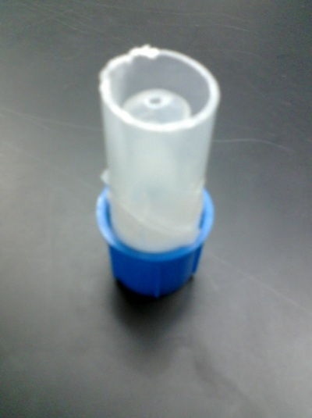
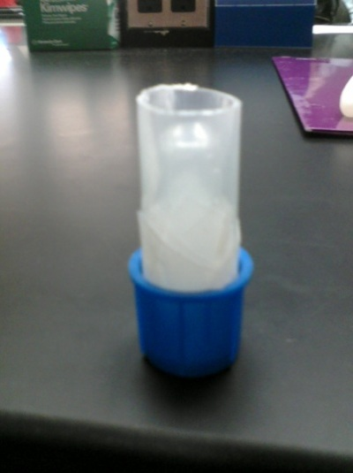
A mold [Fig 1] was created for containing the chitosan/acetic acid mixture during the freeze-drying process. The mold was relatively simple in its design: an inverted cap held two polypropylin tubes, one placed inside the other. The outer tube had been cut to be open on both sides, but the inner tube was closed on one side to prevent the scaffold mixture from leaking in. The outer tube was slightly taller than the inner tube. The mixture was then injected via needle in the space between the two tubes, until it reached roughly 2 mm from the top of the inner tube. The inner tube was stabilized with a plug of Parafilm so as to stay upright in the mixture. The top of the entire mold was then covered with Parafilm as well.
Figure 1: The mold, before injection of the chitosan/acetic acid mixture.
The mold was then placed in methanol pre-chilled to -80 °C, and put in a -80 °C freezer. The purpose of this “pre-freezing” was to prevent the formation of air bubbles within the mixture during freeze-drying, as that would disrupt the process and lead to an incomplete drying of the scaffold. Methanol was used as a heat-conducting medium to steady the rate at which the mixture acclimated to the extremely cold temperature. The mold stayed in the -80 °C freezer for two hours before being transferred to the freeze-dryer. The freeze-dryer froze the mold and then lowered the pressure of surrounding chamber, causing the acetic acid to sublimate and leave behind a porous network of chitosan.
2.3 Scaffold Characterization
After freeze-drying, the some of the scaffolds produced by the class were cross-sectioned and analyzed with the SEM. The scaffolds were cut so that three areas could be visualized: the top, bottom and interior. Pore sizes were measured and pore uniformity, alignment, and interconnectedness were qualitatively compared between the three different sections.

- Results and Discussion
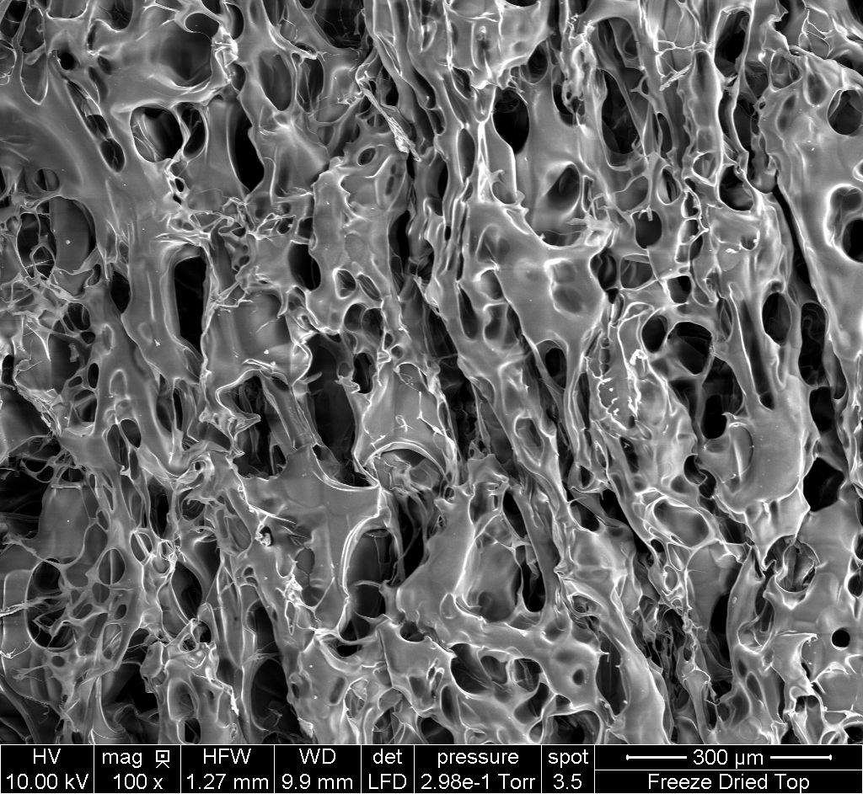
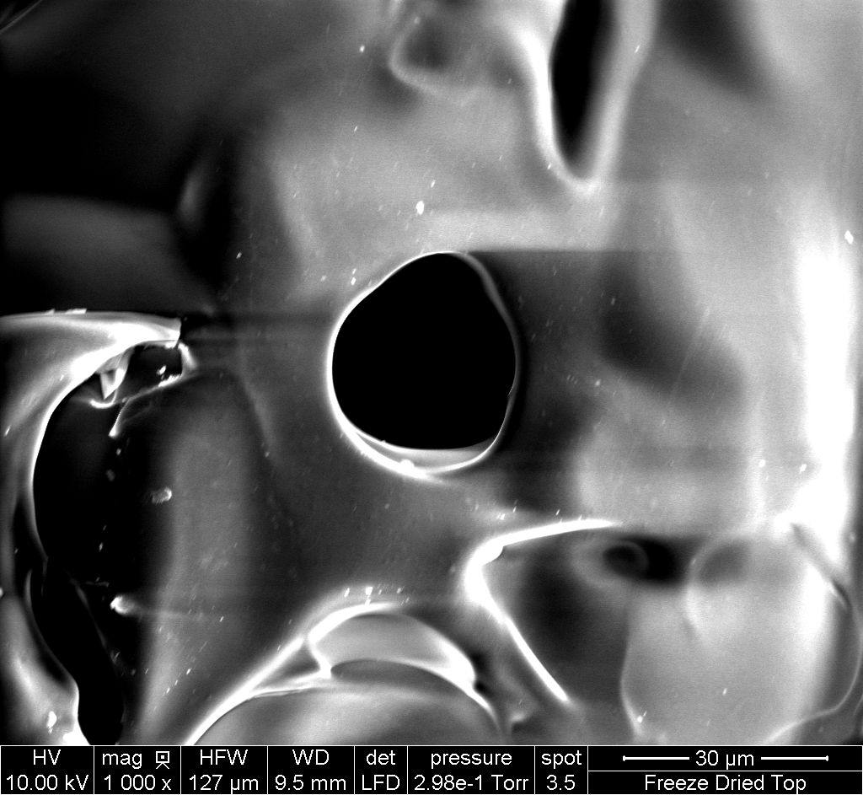
SEM analysis (Fig. 2) showed a large degree of variability of pore structures between scaffold surfaces. The most uniform pore size and structure was exhibited by the inner cross-section. The pores of the top cross-section appear jagged, and the surface of the bottom cross-section appears smooth with a large variety of pore sizes.
A
B
C
D
E
F
Figure 2: SEM pictures of different scaffold cross-sections. A – top, 100x; B – top, 1000x; C – inside, 100x; D – inside, 1000x; E – bottom, 100x; F – bottom, 1000x.
The differences in the cross-sections have everything to do with their relative positions during the freeze-drying process, which influenced the rate at which the acetic acid sublimated. In turn, this rate would have influenced the resulting pore morphology. The scaffold was frozen from the outside in, so the top and bottom cross-sections would have been frozen first. According to Deville et al. [2], the first zones to come in contact with the “freezing front” will experience freezing and sublimation at a much faster rate than neighboring zones. This being said, it is likely that acetic acid in the top and bottom cross sections sublimated faster than in the inner cross-section. In general, it appears that the effect a faster sublimation rate makes for less uniformity between pores; as far as the thickness of chitosan between pores goes, the inside cross-section shows the most uniformity. The bottom cross-section shows some thick walls between pores where others are thin.
Interconnectedness does not seem to be affected, and all three cross-sections show high levels of interconnectedness between pores. Due to the uniformity of the pores and pore structure, the inside cross-section would likely maximize cell viability, however, the other cross-sections would be capable of supporting cells as well.
No major problems were encountered over the course of my involvement with the lab. However, the procedure itself could have been improved with the addition of benchmarks to qualitatively measure the outcome of the scaffold structure. If for example, the target pore diameter was around 100 µm for the ingrowth of osteocytes, the scaffolds would fail miserably because the average pore size measured above was only 30 µm. A comparison between two different scaffolds would have also been interesting; apparently increasing the concentration of the chitosan in solution creates smaller pores and less interconnectivity, while decreasing the concentration does the opposite [3].
A greater study into the effects of freezing should be investigated as well, as the direction of freezing has a great influence on pore structure and alignment [3].

4. Conclusion
The freeze-drying of a chitosan solution caused the sublimation of acetic acid to form a relatively uniform pore size of 30 µm in the resulting scaffold. Due to the scaffold being frozen from the outside in, pore structure and interconnectedness varied between cross-sections of the top, bottom, and inside of the scaffold. Overall, the inner cross-section showed the most interconnected pore structure, and as a result would likely be the most biocompatible.
References
[1] Nettles DL, Elder SH, Gilbert JA. Potential Use of Chitosan as a Cell Scaffold Material for Cartilage Tissue Engineering. Tissue Engineering: Mary Ann Liebert, Inc 2002; 8:1009-1016.
[2] Deville S, Saiz E, Tomisa AP. Freeze casting of hydroxyapatite scaffolds for bone tissue engineering. Biomaterials: Elsevier 2006, 27:5480-5489.
[3] Madihally SV, Matthew HWT. Porous chitosan scaffolds for tissue engineering. Biomaterials: Elsevier 1999, 20:1133-1142.

Appendix
Scaffold Fabrication: Freeze Drying Protocol; edited by Reem Daher-Nahhas (see attachment)

I have neither given nor received any unauthorized aid in completing this work, nor have I presented someone else’s work as my own.

_____________________________________________

