Collagen Fiber Extrusion

Emily Boggs

Biomedical Engineering Program, Lawrence Technological University

Abstract: The creation of self-assembling collagen fibers was attempted by an extrusion method. Different concentrations of collagen dissolved in 10 mM HCl were pushed through a syringe pump into a beaker of extrusion buffer. The buffer contained salt, Trizma, and sodium phosphate dibasic. It was confirmed that a collagen solution concentration of 10 mM is adequate for fiber formation; the extrusion of a lower 3.3 mM collagen solution failed to produce fibers. The fibers were then dried and mechanically tested for tensile strength.

Keywords: collagen, self-assembly, fibrils, syringe pump extrusion

- Introduction
Collagen I is an extremely popular material for use in tissue engineering, due to its elasticity, tensile strength, and biocompatibility. In fact, when it comes to biocompatibility, no other material can beat out collagen. A tissue found naturally in the body, collagen I can be harvested from biological sources or secreted by fibroblasts in a laboratory. Collagen I is naturally fibrous and lends its strength to connective tissue like ligaments and tendons. Many tissue engineering applications seek to exploit the fibrous mechanical properties of collagen I. However, a problem comes in the formation of organized fibrils: collagen harvested from biological sources is often not in a fibrous form, but chopped into small pieces and aggregated into clumps. One solution is to use pressure to reform collagen aggregates into a basic fibril shape and deposit it into a warm buffer solution. Once in solution, collagen particles precipitate out and begin self-assembling into a linear shape, producing fibrils. [1]
This procedure included the use of collagen I harvested from rat tails. The collagen was mixed into a dilute solution of HCl and extruded into a warm buffer solution. The resulting change in temperature and pH for the solution caused the particles to precipitate out and form fibrils.

- Materials and Methods
  - Materials
- 2 Collagen solutions of 3.3 mg/mL and 10 mg/mL in 10 mM HCl
- Extrusion buffer
  - Sodium phosphate dibasic
  - Trizma
  - NaCl
- 10 mL syringe
- Syringe pump (Harvard Apparatus)
- 12 M HCl
- pH meter
- 20 gauge catheter
- Isopropyl alcohol
- Distilled water
2.2 Fiber Fabrication
Two solutions were prepared from the rat tail collagen in 10 mM HCl. One had a concentration of 3.3 mg/mL collagen, and the other 10 mg/mL. An extrusion buffer in which fibril formation could take place was also made. The concentrations of each component were 135 mM NaCl, 30 mM Trizma, and 30 mM sodium phosphate dibasic. In a 250 mL solution, this translated to masses of 1.9722 g NaCl, 0.9080 g Trizma, and 1.0651 g sodium phosphate dibasic measured out for each solvent. The resulting pH of this solution was 9.5. To bring the pH down to neutral levels (~7.5), 12 M HCl was added drop by drop (roughly 0.05 mL per drop) while the solution was monitored with a pH meter. The buffer solution was eventually brought down to a pH of 7.55 after the addition of 17 drops. The top of the beaker was then covered with aluminum foil and placed in a water bath until it reached 37 °C.
For each collagen solution:
A 10 mL syringe was filled with the collagen solution and attached to a 20 gauge catheter. The syringe was placed in the syringe pump and the end the catheter was submerged in the warm buffer solution. The syringe pump extruded the collagen solution through the catheter at a rate of 0.7 mL/min. After the extrusion process, the collagen was left in the buffer solution for 45 minutes, during which it self-assembled into fibrils. Then, the fibrils were transferred to isopropyl alcohol and left overnight. The fibers were then submerged in distilled water for 30 minutes. Finally, they were placed on racks and left to dry for 24 hours at room temperature.
2.3 SEM Analysis and Mechanical Characterization of the Fibers
Once dried, two fibers each were placed across “slides;” the slides were rectangular in shape, with two small pieces of plastic at the opposite narrow ends and two slips of paper for the long sides. The fibers were attached to the plastic ends via epoxy. After placement into the 1 N force transducer and just before placement into the SEM for characterization, the two slips of paper were cut, leaving the fibers as the only means of attachment between the pieces of plastic. The fibers were then visualized with SEM, and measurements for fiber length and diameter were taken.
For mechanical testing, a measurable tensile force of increasing increments was applied to the fibers and a camera recorded the resulting elongation of the fibers. The force and elongation are measured for as long as it takes before the fibers break. The resulting force and elongation data, when combined with measurements of diameter (area) and initial length, are enough to construct a stress-strain curve from which the elastic moduli of the fibers can be found.

3. Results and Discussion
The extrusion of collagen at the concentration of 3.3 mg/mL was unsuccessful; the concentration was too low as not enough collagen was present to assemble into macroscopic fibers. The extrusion of the 10 mg/mL solution was successful, however, and produced fibers suitable for mechanical testing.

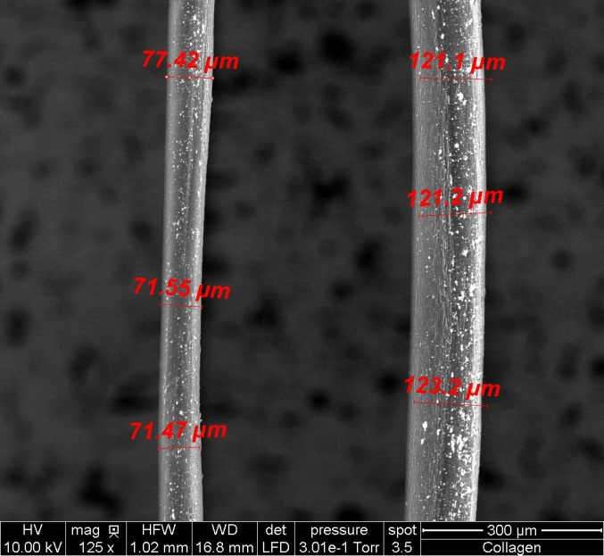
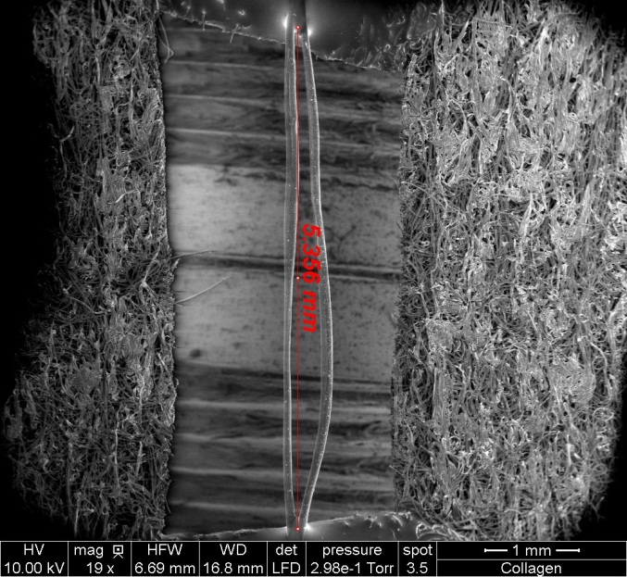
Figure 2: The diameters of both fibers. Three measurements were taken for each fiber and averaged. The fiber on the left produced the only usable data.
Figure 1: The average length of both fibers.

Two fibers were measured for their length (a rough average of the two; Fig. 1) and individual diameters (Fig. 2). Though both fibers underwent mechanical testing, only one presented usuable data, as the other fiber on the slide did not break but instead pulled away out of its epoxy anchoring. Using the force and elongation data collected from the one fiber, a stress-strain curve was produced.
Chart 1
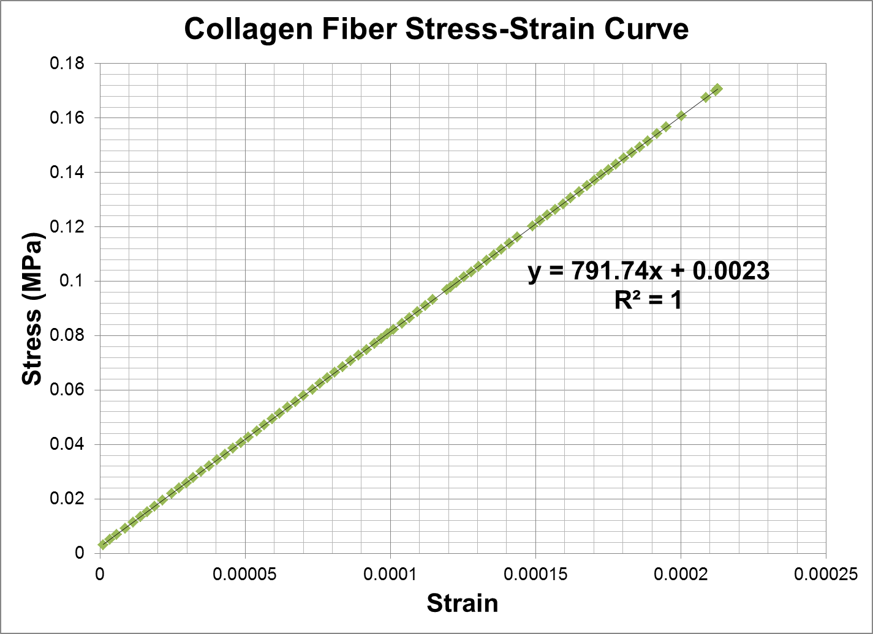
The elastic modulus for the collagen fiber, according to the Chart 1, is 791.74 MPa. Unfortunately, it is difficult to compare this number with other elastic moduli measured for collagen, as the modulus varies greatly depending on the thickness of the collagen (which can change depending on how much it is stretched) and whether it was wet or dry at the time of testing. Pins et al. [2] found that the elastic modulus of collagen fibers soaked in PBS for an hour prior to characterization ranged from 250 to 540 MPa, depending on how much the fibers were stretched (stretched fibers exhibited higher moduli). The modulus for our tested fiber, 791.74 MPa, is much higher, but this is to be expected since drier fibers will likely test stiffer than wet ones. This variety may be due to the presence of viscoelastic properties within the very molecular structure of collagen; hydrogen bonding may be responsible [3].
The only problem encountered in this lab was the detachment of one of the collagen fibers from the epoxy. However, none of the other fibers tested experienced this, so the detachment is likely just an uncommon occurrence. However, the rigging of the fibers to the slides with epoxy may have contributed to a higher stiffness if any epoxy managed to coat even a small amount of free fiber. Other ways in which to rig these fibers for mechanical testing should be looked into.

4. Conclusion
Collagen fiber extrusion was successful at a collagen concentration of 10 mg/mL. The dry fibers’ lengths and diameters were measured via SEM and underwent a tensile force test. The calculated elastic modulus for the measured fiber was 791.74 MPa, predictably significantly higher than the elastic moduli of the wet collagen fibers tested by Pins et al.

References
[1] Wake Forest University. Musculoskeletal Tissue Regeneration Laboratory. Virginia Tech: School of Biomedical Engineering and Sciences. Online. 2012. Available from URL: http://www.sbes.vt.edu/freeman/video_collagen.html
[2] Pins GD, Christiansen DL, Patel R, Silver FH. Self-Assembly of Collagen Fibers. Influence of Fibrillar Alignment and Decorin on Mechanical Properties. Biophysical Journal: Biophysical Journal 1997; 73:2164-2172.
[3] Sasaki N, Odajima S. Stress-strain curve and young's modulus of a collagen molecule as determined by the X-ray diffraction technique. Journal of Biomechanics: Elsevier, 1996; 29:655-658.

Appendix
Collagen Fibers Extrusion Lab protocol; edited by Reem Daher-Nahhas (see attachment)

I have neither given nor received any unauthorized aid in completing this work, nor have I presented someone else’s work as my own.

_________________________________________

