Isolation and Quantification of Capsaicin from Hot Sauce

Emily Boggs

ABSTRACT: Different hot sauces have different quantities of capsaicin. Since capsaicin interacts with sensory neurons to cause the sensation of “hotness,” milder sauces should have less capsaicin content than hotter ones. The determination of capsaicin levels in three hot sauces with varying degrees of “hotness” was carried out by removing and purifying the capsaicin from samples of each. The concentration of capsaicin was determined comparing the absorbance levels between the samples and a solution of pure capsaicin.



Figure 1. The molecular structure of capsaicin.

C

apsaicin is a naturally occurring molecule found in the fruit of plants of the *Capsicum* genus – in other words, most hot peppers. It is also present in much smaller quantities in cinnamon, oregano, and cilantro. Capsaicin is what causes the sensation of “hotness” in these foods. The molecule binds to lipoprotein nocireceptors on the surface of epithelial cells, specifically the transient receptor potential vanilloid receptor (TRPV1). The sensation triggered by capsaicin is an intense, long-lasting burning, similar to an actual burn caused by heat. It evolved as a means to prevent mammals (who have these receptors) from eating these fruits while allowing birds (who do not have these receptors) to ingest the seeds. The likely reason is because the digestive systems of birds are more suitable for carrying these seeds.

The key to capsaicin’s ability to bind to these receptors lies in its long hydrocarbon tail (Figure 1), as TRPV1 also contains long strings of hydrocarbons. The molecule’s lipid-like structure can also allow it to permeate past cell membranes, making the sensation long lasting. Certain molecules very similar to capsaicin (capsacinoids) differ only in the structure of this tail. These minute differences can be enough for receptors to distinguish between capsacinoids, causing burning sensations in different areas, like in the throat versus the mouth. The long tail also affects capsaicin’s solubility in water; the long stretch of hydrocarbons makes it mostly insoluble. The high molecular weight of capsaicin (compared to other vanilloids like eugenol and zingerone) makes its volatility very low, as well as the –NHCO- group that promotes strong intermolecular bonding. It is also odorless, though exists only in particulate form while in the air. If inhaled, capsaicin can still cause intense irritation of the respiratory tract. However, the reception of capsaicin in the body can cause a release of pain-killing endorphins, giving a pleasant rush. This is likely why capsaicin is a widely-used flavoring.

The amount of capsaicin in a given pepper is measured in Scoville Heat Units (SHU; Figure 2). Hot sauces can be expected to exhibit the same relative SHU as the pepper they are made from, i.e., a sauce made from jalapeños will be hotter than one made from poblano.

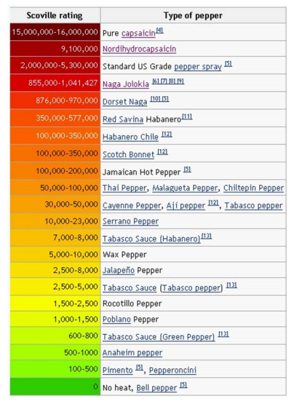

Figure 2. The measurement of Scoville Heat Units in different types of peppers.

The procedure began with a blind taste test of the three hot sauces from which capsaicin would be isolated. Afterward, the samples were revealed as Tabasco ® brand: Original, Green Pepper, and Habanero. The purpose of the test was to infer the order of capsaicin content in the hot sauces by taste alone. The hypothesis formed placed sauce number two (Habanero) as hottest and sauce number 1 (Green Pepper) as the mildest.

After the taste test, 3 mL of each sauce was poured into pre-weighed Erlenmeyer flasks. Diethyl ether was added, and the resulting solutions were stirred for 15 minutes. During that time, two layers formed in each the flask; the bottom layer consisted of the bulk material from the hot sauce, while the top layer contained capsaicin dissolved in diethyl ether.

This upper layer was then carefully removed and gravity filtered into a clean flask. A small amount of additional diethyl ether was introduced into the bulk material and spun for one minute. The top layer was again filtered. This process was repeated once more to ensure that all the capsaicin in the sample was extracted. The flasks of capsaicin solution were then left in a fume hood uncovered for a week, allowing for the complete evaporation of the diethyl ether.

In the next lab session, the flasks were weighed again, allowing for the determination of the weight of the dry capsaicin. The next step would be to prepare a set of capsaicin dilutions in methanol for spectrophotometry. The solutions on the microliter plate included two pure, two 1/10, and two 1/100 dilutions for each hot sauce. To create a standard absorbance curve, dilutions of a stock capsaicin/methanol solution of 1 mg/mL were also created. Using the Beer-Lambert law, the capsaicin concentrations in each sample could be ascertained.

Based on the taste test, it was hypothesized that the Habanero sauce would contain the most capsaicin and the Green Pepper sauce the least. This hypothesis was partly validated. The capsaicin dry weights for each sauce were as follows:

Habanero: 0.0065 g

Original: 0.0234 g

Green: 0.0008 g

Clearly, the Green Pepper sauce contained the least amount of capsaicin. However, the Habanero sauce, which was perceived as the hottest, had significantly less capsaicin than the Original Pepper. Given these values, it is possible to give a theoretical estimate of what the capsaicin concentrations might be, given that the capsaicin in the flasks were each derived from 3 mL of sauce:

Habanero: 2.17 mg/mL

Original: 7.80 mg/mL

Green: 0.200 mg/mL

According to these figures, the capsaicin content in the Original Pepper sauce is over three times greater than the amount found in the Habanero sauce. The validity of this statement was not consistently upheld by the data from the spectrophotometer, however. The estimated concentrations could also be inaccurate because not all capsaicin in the sample was purified.



Table 1. Microliter plate layout.



The data from Table 1 shows the layout of solutions in the microliter plate and their corresponding absorbances as detected by the spectrophotometer. The colored columns show dilutions of the stock solution, except for the very top row, which shows the concentrations of capsaicin in the stock dilutions in mg/mL. Note that as the concentration increases, the absorbance also increases. In greyscale are the absorbances recorded for the hot sauce samples; the shading is meant to represent the relative concentration of capsaicin in each dilution compared to the others.

Since the stock dilutions clearly show a direct relationship between absorbance and capsaicin concentration, the hypothesis would assume that the Habanero sauce would have the highest capsaicin content for all dilutions. This was true in all but two instances, which are bordered in red. In these cases, the absorbance for the Original Pepper sauce was higher for the same dilution. The absorbances for both the Habanero and Original Pepper sauces are far above those of the Green Pepper sauce.

To translate the absorbances of the hot sauce samples into concentrations, a standard absorbance curve was generated from the average absorbances from each stock dilution (Figure 3). From the curve, the equation “absorbance = 2.0186 x concentration” is obtained. Substituting in the measured absorbances gives concentrations (in mg/mL) of capsaicin for the hot sauces (Figure 4).

However, the results of these concentrations are not clear. Each set of dilutions appears relatively consistent between the hot sauces, but the 1/100 dilutions, after their concentrations are multiplied by 100, are different from the undiluted samples by a magnitude of ten. The 1/10 concentrations also appear to be twice as large as the undiluted concentrations. None of the concentrations seem anywhere near the estimated concentrations. However, these numbers seem to arise when the trendline for the curve is snapped to a (0,0) intercept. When following the natural curve, the concentrations for 1/100 are much smaller, but negative (Figure 5). My lab partner received this error. What caused this major discrepancy is unknown. Both lab partners received similar results in magnitude. Each one made their own dilutions separately, but from the same stock and same samples. Since the results were uniform between the two partners, individual error must not be a factor. The capsaicin/methanol solutions could not have been the source of error as dilutions of the same solution, when adjusted, should show the same concentration. The error could not have been in the making of the dilutions themselves, as two people working separately would not likely make the same dilution mistake. The pipetting techniques between partners were different, yet both led to the same magnitude of error. Indeed, the case of the absorbance of the Original Pepper being greater than the absorbance of the Habanero in the undiluted and 1/100 samples was also present in my partner’s data.

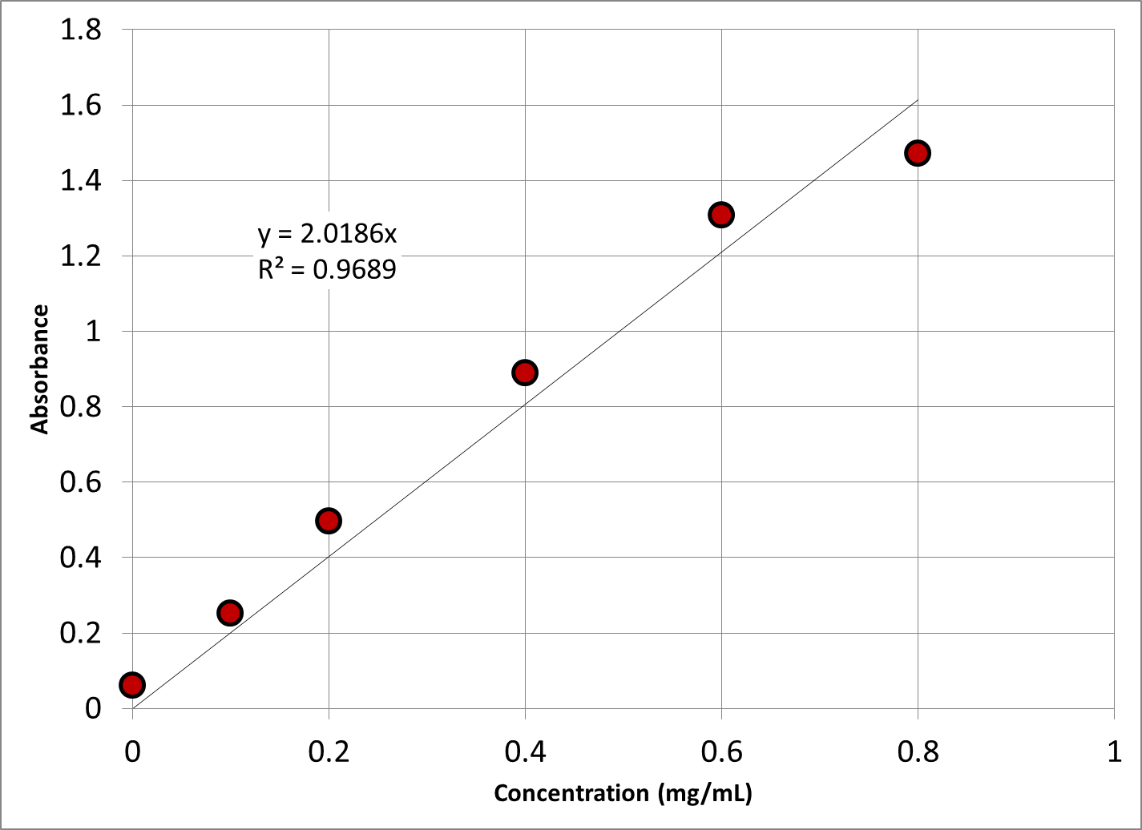

Figure 3. The standard absorption curve as given by the absorbances of known capsaicin concentrations. Note at the bottom the average absorbance for each stock sample; these values were used to create the curve.

Regardless, the overall results still supported the hypothesis. Habanero, as the hottest, had the most capsaicin (except in two cases). The Green Pepper sauce had the least amount. It would have been nice if spectrophotometer data was shared amongst different lab teams. That way, in the case of one team getting a major discrepancy, they can check to see if others are showing the same type of error. At the very least, it could be used to establish a range for the capsaicin concentrations. Also, the exact amounts of capsaicin in the three hot sauces are not actually known, so the exact concentrations can never be verified. Though hypothesizing the order in which the hot sauces range from hot to mild is rewarding, it would be even better to know how close the concentrations calculated are to the actual number. However, upon retrospection, trying to determine just the order of the hot sauces is this experiment’s strength, as the order is still attainable with error-ridden data. Also, the reliability of hot sauces and spicy food make this procedure more interesting to the average biochemistry student. The use of familiar substances makes the lab and the techniques and concepts it teaches approachable.



Figure 4. Concentrations of hot sauce samples as calculated from the absorbance curve in Figure 3. All concentrations are in mg/mL.

ACKNOWLEDGMENTS

I’d like to thank Dr. Timmons for enabling me to perform this procedure. I would also like to give special thanks to the time she spent past noon on our first lab period so we could finish. Of course, thanks and acknowledgement are given to my extremely patient lab partner Jaime Willbur, who not only took the time to show me analytical techniques, but kindly tolerated my occasional bouts of obliviousness. Thank you Jaime! I would like to thank Ashley Croft and Joshua Wells for coming up with such a cool experiment. In all seriousness, I would also like to thank Lawrence Technological University for providing me with the financial support to study under professors like Dr. Timmons, and share my learning experiences with students like Jaime.

**REFERENCES**

1. Croft A., and Wells J. (2012) Isolation and Quantification of Capsaicin from Hot Sauces, pgs. 4-6.
2. Senese F. "Fire and Spice: the molecular basis for flavor." General Chemistry Online. Frostburg State University, 15/2/2010. Web.
3. National Pesticide Information Center, . "Capsaicin Technical Fact Sheet." National Pesticide Information Center. Web.
4. Veronesi B., and Oortgiesen M. "The TRPV1 Receptor: Target of Toxicants and Therapeutics." Toxicological Sciences. 89.1 (2006): 1-3. Web.