A Review of “Modeling aqueous humor collection from the human eye”
Konstantinos Kapnisis, Mark Van Doormaal, C. Ross Ethier
Department of Bioengineering, Imperial College London

Review by Emily Boggs

Abstract
The authors of the article being reviewed have created several computer simulations of the fluid movement inside the anterior chamber of the eye during aqueous humor aspiration. Since the proteins in the aqueous humor are not uniformly distributed and tend to pack in what is called the “angle” of the anterior chamber, their goal was to determine whether current aspiration techniques collect any fluid at all from these highly-concentrated areas. In addition to a baseline model created from the average measurements of over 600 subjects, these researchers tested different parameters concerning the chamber and the needle: size, shape, placement, and so on. The result was that despite these variations, all but one of the models showed the aspiration of fluid only from the center of the anterior chamber.

Introduction
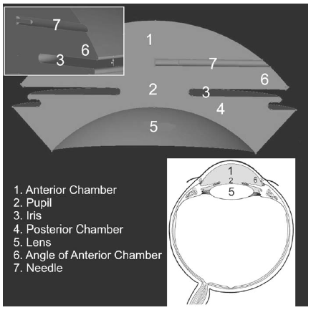
Figure 1: A simple computer model of structures of the eye during AH aspiration (Kapnisis, K, et al., 2009). Note the position of the needle (7) relative to the angle of the anterior chamber (6).
Recently, researchers studying open-angle glaucoma have discovered that in persons with the condition, the composition of proteins in the aqueous humor (AH) is abnormal. As a result, there has been a push for the collection and analysis of aqueous humor. AH is often collected from subjects undergoing eye surgery via aspiration by needle from the anterior chamber of the eye (Fig. 1). However, there has been some concern as to whether the samples collected using this technique are accurate, as the distribution of proteins in the aqueous humor is not uniform.
Glaucoma is a condition that often leads to permanent eye damage or blindness to those it afflicts. According to one source (Quigley, H.A, 1996), glaucoma is the second leading cause of blindness in the world. Glaucoma is characterized by an increase of pressure within the eye, which may be caused by a blockage of the channel-like tissues (trabecular meshwork) that allow for the drainage of AH. What causes this blockage or obstruction in the tissue is unknown, and currently a major topic of research (Kapnisis, K, 2009). However, several projects in the last 20 years have shown evidence that the culprit may be an errant protein.
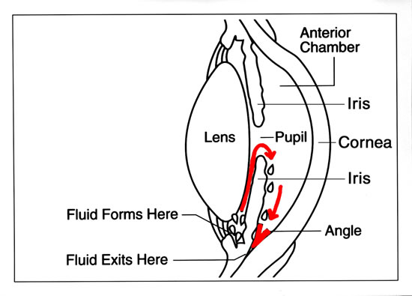
It began with the analysis of AH from patients with different eye conditions. These samples are taken usually with the intent of using them for scientific research and are collected from patients during eye surgery. In the past 20 years, researchers (Liton, P.B, et al., 2005; Picht, G, et al., 2001; Tripathi, R.C, et al., 1994) have noted that the AH in patients who were undergoing glaucoma surgery had a different protein composition from, say, patients undergoing surgery for cataracts. This evidence was little more than a scientific curiosity until 2005, when a group a researchers (Fautsch, M.P et al., 2005) discovered that the proteins in AH had a regulatory effect on the characteristics expressed by the trabecular meshwork. It was easy for researchers to put the chain of concepts together: glaucoma is caused by trabecular obstruction; trabecular growth is regulated by proteins in the AH; people affected with glaucoma have abnormal levels of certain proteins in their AH. In one study (Nolan, M.J, et al., 2007), the incidence of glaucoma could be directly correlated with high levels of a protein called sCD44. It is still unknown whether high levels of this protein cause glaucoma, or the other way around. This study also shows that in subjects who had previously undergone surgery for glaucoma, the levels of sCD44 (7.32+/-1.44 ng/mL) in their AH were in between the levels of the control group (5.88+/-0.27 ng/mL) and the levels of subjects with untreated glaucoma (12.76+/-0.66 ng/mL).
Figure 2: The pathway taken by solutes (mostly proteins) secreted by the ciliary body (http://primesight.net/education.htm). In glaucoma, this pathway is blocked, leading to increased pressure within the eye.
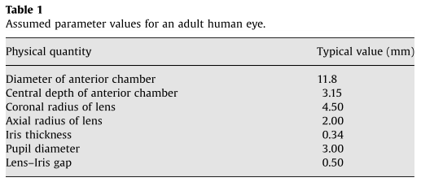
Clearly, for the future of glaucoma research, the methods of acquiring these AH samples must be standardized as much as possible. Also, investigations must be made into whether current AH aspiration techniques are collecting accurate samples. Only a few months before the article describing the correlation of sCD44 and glaucoma was published, the journal Investigative Ophthalmology and Visual Science ran an article (Bert, R.J, et al., 2006) for a project that sought to prove if the human eye has a diffusional pathway for solutes from the ciliary body (where proteins are made) to the anterior chamber. The existence of this pathway had already been proved in rabbits (Freddo, T.F, et al., 1990) and owl monkeys (Barsotti, M.F, et al., 1992) using fluorescent tracer proteins. When studying the human eye, however, these researchers opted to use MRI with the help of intravenous gadolinium-based contrast agents. Though only seven subjects were tested, substantial evidence was gathered to prove the existence of the solute pathway (Fig 2). In addition, it was found that the solutes – once they were free of the pathway – tended to congregate in what is called the “angle” of the anterior chamber. This was consistent with the behavior of the fluorescent tracer proteins in the monkeys and rabbits as well. These three studies all seemed to point that if there are glaucoma-indicative proteins in the AH, they can be found in the anterior chamber’s angle.
The purpose of the study “Modeling aqueous humor collection from the human eye” was to see if current aspiration techniques are capable of acquiring AH from these small, protein rich corners of the chamber. To this end, the research team created several models of AH flow in the anterior chamber and simulated how the fluid would react during aspiration.

Materials and Methods
To create their baseline model, the team used the modeling program ANSYS ICM. For size-related parameters, they drew data from a study (Fontana, S.T, et al., 1980) that measured the volume of the anterior chamber in 624 subjects. In addition to taking the measurements, this study also found that the volume of the anterior chamber decreases with age, and, based on the distributions of these measurements, were able to extrapolate anterior chamber volumes for older patients. Kapnisis et al. used these extrapolations for their baseline model of an anterior chamber belonging to someone between the ages of 41 and 50 years old (Table 1). All of the models created, including the baseline, assumed symmetry for reasons of simplification.
A 30-gauge, needle was used for aspiration in the model. It was inserted parallel to the lens through the corneal limbus, where the cornea and sclera meet. In the baseline model, the needle was inserted about halfway across the anterior chamber.
For modeling the fluid flow, it was assumed that the aqueous humor would have the same physical properties as saline solution at 37 °Celsius. The authors base this assumption on the work of three separate studies (Beswick, J.A, et al., 1956; Hoffert, J.R, et al., 1969; VanBuskirk, E.M, et al., 1974). For the speed of the aspiration, the baseline model used 8 µL/s, based on the typical surgical aspiration speed of 40 µL In 5 seconds. To model the fluid mechanics of the aqueous humor, the team used a Reynolds number of 105.2 (A more detailed look into the source of this number is taken in the Summary section).
The most significant assumption made by Kapnisis et al. in modeling the fluid flow stems from the difficulty in accurately demonstrating anterior chamber collapse during the aspiration of 40 µL. During sampling in real subjects, the anterior chamber actually “deflates,” as a significant portion of its total volume is aspirated. The mean volume measurement of a living subject’s eye (Fontana, S.T, et al., 1980) is only about 199 ± 48 µL, not to mention the extrapolations made to predict the smaller volumes of older eye parameters being used by the authors. As a result, in order for the model to be anywhere near accurate, partial chamber collapse must be taken into account.
As changing the shape of the eye model mid-simulation would be extremely difficult, a more clever solution was found. To preserve the shape and volume of the anterior chamber, during the simulation, fluid was created at the tissue surrounding the posterior and anterior chamber at a rate to balance the aspiration.
The model’s mesh was developed by solving the Navier-Stokes equation in three dimensions. The calculations were carried out by software using the finite element method. This software had been evaluated in detail by one of the authors in two previous articles (Ethier, C.R, et al., 1998; Ethier, R.C, et al., 1999). In addition, the subsequent refining of meshes that that took place were documented in another article published a year before (Kapnisis, K, 2008).
In addition to the baseline model, several models with variations in the parameters described above were also simulated, seven in total:
- Doubled aspiration speed, from 5 µL/s for 8 s to 10 µL/s for 4 s
- Halved aspiration speed, from 5 µL/s for 8 s to 2.5 µL/s for 16 s
- Fluid introduced to prevent chamber collapse only came from the anterior chamber
- A structurally simplified reduction of volume by 40 µL during the aspiration process
- Needle introduced not halfway across the chamber but 3/4 of the way through
Figure 3: From the article (Kapnisis, K, et al., 2009): “Contours of fluid speed on the model symmetry plane and fluid streamlines…In the streamline plot, balls are placed at 1 s intervals, i.e. the balls closest to the needle tip indicate fluid that reaches the needle in 2 s, etc. The balls furthest from the needle tip therefore delimit the fluid that is collected during the 5 s aspiration process. Speeds have been made dimensionless with respect to the mean fluid speed in the needle.”
- Needle with 45° beveled tip
- The gap between the lens and the iris decreased to 0.05 mm
The goal was to see if any of these parameters changed the regions within the anterior chamber from which the fluid was aspirated. These regions would be indicated by the relative speeds at which the simulated fluid particles would move to the needle tip. For modeling these particles, both streamlines and continuous color contours would be used.
Results and Article Conclusion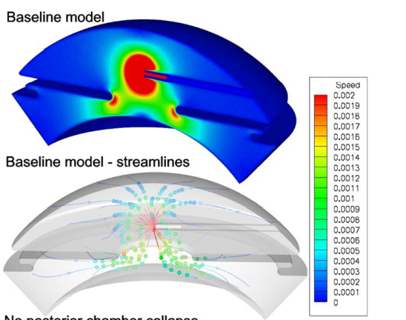
Recall that the goal of this project was to determine if fluid was being collected at all from the protein-rich corners of the anterior chamber. As demonstrated in Figure 3, in the baseline model, the fluid aspirated from the chamber came almost exclusively from the center. All but one of the variations carried the same result: the most promising simulation was number five, where the needle was inserted three quarters of the way through the chamber. As a result, the tip of the needle was almost inside the corner (Figure 4). Even then, most of the aspirated fluid came from a very restricted area around just outside of the tip.
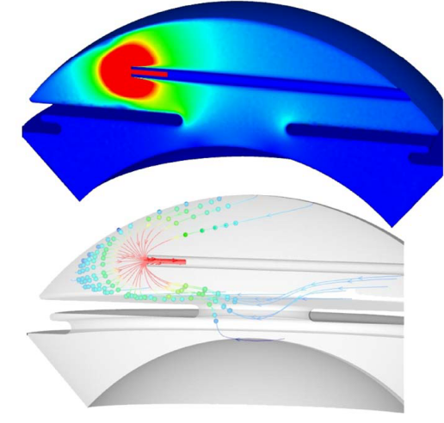 In the discussion, recommendations are made that during an aspiration procedure, the needle should be inserted further into the chamber, at least three-quarters of the way across (or one quarter, though this variation was not tested). In addition, the development of new surgical techniques for collecting aqueous humor is suggested, preferably as close as possible to the corner of the anterior chamber. For further experimentation, Kapnisis et al. suggest that the next team to tackle this type of aqueous humor aspiration modeling should try to model anterior chamber collapse as closely as possible, complex though it may be. However, they remain confident that their own models are accurate, despite having to compensate for chamber collapse in a relatively unorthodox way by supplying fluid into the system; they maintain that dimensional changes during the simulation are probably not very significant anyway, as all the models run with variations on chamber dimensions gave similar results to that of the baseline. Further variations from those described in the text are also suggested.

Personal Reflections and Summary
Presentation of background information
This article, though short, specific, and filled with eye-catching diagrams, is not particularly approachable by any reader outside the field of glaucoma study, thus the reason in this review for the extensive amount of background information. When fact checking the sources cited by this article, I often ran across the same names again and again. It was interesting when I finally realized that I could trace a progression present in some of the papers written in the past 20 years. For example, one paper (Freddo 1990) examined the source of aqueous humor proteins in rabbit eyes; a few years later, another paper (Barsotti 1992), inquired the same of owl monkey eyes. Both papers were by the same four authors (Barsotti, Bartels, Freddo, Kamm) but their names were in different orders for each paper, making the connection less apparent at first. Both of these papers were seminal in producing this one, as they laid groundwork for tracing protein pathways in the eye, and pinpointed the corners of the anterior chamber as an area where these proteins congregate.
Figure 4: Variation #5, inserting the needle 75% of the way across the anterior chamber.
Noticeably absent was a paper in the same vein but with human subjects; I suppose this is to be expected. It wasn’t until more than ten years later that another paper (Bert, R.J, et al., 2006) covered this ground, but instead of implementing invasive procedures and posthumous examinations, used injected tracer proteins and MRI. The authors of this paper were all new, with the exception of Dr. Freddo’s name listed at the very end.
It is easy to see, then, that this work seems to be concentrated within a circle of just a few researchers, and, likely in the case of Dr. Freddo, their students. The authors of the article reviewed in this paper had also published their work with anterior chamber meshes the year before publishing this one. One of the authors, Ethier, had also published an article on computer modeling, but of arterial grafts (Ethier, R.C, et al., 1998).
The implication is the authors of this article had a specific audience in mind, i.e, glaucoma researchers and those who are familiar with making computer models of biological systems. A person unfamiliar with these fields might be put off by the sudden drop into obscure (though certainly not insignificant) research. At first glance, the paper is very frustrating, particularly with the brevity in which it covers some of these subjects. However, the situation is remedied elegantly by the inclusion of the in-text citations, so that curious or even skeptical readers can find the basis for many of the assumptions made, provided they can access these other articles.

Explanations of steps taken in the procedure
Some of the steps in the article were explained a little too briefly for my taste. For example, their calculation of the fluid’s Reynolds number.
Although the equation used to calculate this value is not explicitly given, the article states that this number was calculated from mean needle lumen velocity and diameter. Since the mean needle lumen velocity is not given, it is not possible for someone to reconstruct this exact equation. However, the Reynolds number can be approximated using:
$$R_{e}=\frac{Q D_{H}}{v A}$$
Where Q is the volumetric flow rate (m³/s), D_{H} is inner diameter of the needle (m), A is the cross-sectional area of the lumen (m²), and v is the kinematic viscosity (the dynamic viscosity divided by density) of the aqueous humor (m²/s). Using the data supplied in the text of the article, the following values can be applied:

Q is 8 µL/s = 8x10⁻⁹ m³/s
D_{H} for a 30-gauge needle is 0.159 mm = 1.59x10⁻⁴ m
A for a cylindrical 30-gauge needle is 1.99x10⁻⁸ m²

As for v, the kinematic viscosity of the saline solution (the stand-in for aqueous humor) cannot be found because the concentration the authors used is not given. However, solving the equation backwards for v gives 6.08x10⁻⁷ m²/s, which is close to the kinematic viscosity of pure water: 6.58x10⁻⁷ m²/s at 40 °Celsius. Therefore, we can assume that a Reynolds number of 105.2 is accurate.
In addition, the authors’ descriptions of the developing the meshes for the model using a finite element package and Navier-Stokes equations were very brief. This is understandable; the same authors had just published a paper less than a year before this one in which they presumably gave more detail into the process. However, this paper is only available to members of the Imperial College London. It would have been nice if the paper that they had referenced all their work to was available to everyone.
It would have also been nice if the authors had explained more about the variation of parameters taken in the non-baseline models, not necessarily what the variations were, but why they were chosen. No explanations were given or outside articles referenced when these models were listed in the text. Most confusing was the business with the gap between the iris and the lens; in the chart they provide (Table 1 in this paper) based on the human measurements taken by Fontana, this gap is listed as 0.5 mm. However, in simulation number seven, the gap is reduced to 0.05 mm to match “a more physiologic value” – a factor of ten! Nowhere in the article is this discrepancy addressed; even a short statement describing why they had chosen to model 0.5 mm in the first place would have been welcome. It is also possible that this discrepancy is caused by a typo, though this is unlikely since the authors specifically mention decreasing the gap to 0.05 mm in the seventh simulation. Perhaps a different-sized gap is common to people with open angle glaucoma? Again, any explanation would have been welcome.
Nevertheless, there were still parts of the procedure that impressed me, specifically compensating for anterior chamber collapse by supplying fluid at the same rate it was withdrawn. I skeptical at first, but then came to accept the scenario as an acceptable assumption, especially when the results were not significantly different from the fourth simulation, where a simplified deflation of the anterior chamber was modeled.

Implications
If the models in this paper are accurate, and we have reason to believe so, then the world, however small, of glaucoma researchers should be shaken! Clearly the steps taken during AH aspiration are not providing accurate samples for protein analysis.

Works Cited
Barsotti, M., Bartels, S., Freddo, T., & Kamm, R. D. (1992, March). The source of protein in the aqueous humor of the normal monkey eye. Investigative Opthalmology & Visual Science, 33(3), 581-595.
Bert, R.J, Caruthers, S.D, Jara, H, Krejza, J, Melhem, E.R, Kolodny, N.H, et al. (2006, Dec). Demonstration of an anterior diffusional pathway for solutes in the normal human eye with high spatial resolution contrast-enhanced dynamic MR imaging. Investigative Opthalamology & Visual Science, 47(12), 5153-62.
Beswick, J.A, & McCulloch, C. (1956). Effect of hyaluronidase on the viscosity of the aqueous humo. British Journal of Opthalmology, 40(9), 545-548.
Ethier, C.R, Steinman, D.A, Ojha, M, Xu, X.Y, & Collins, M.W. (1999). Comparisons between computational hemodynamics, photochromic dye flow, visualization, and MR velocimetry. Computational Mechanics Publications, 131.
Ethier, C.R, Steinmen, D.A, Zhang, X, Karpik, S.R, & Ojha, M. (1998). Flow waveform effects on end-to-side anastomotic flow patterns. Journal of Biomechanics, 31(7), 609-617.
Fautsch, M.P, Howell, K.G, Vrabel, A.M, Charlesworth, M.C, Muddiman, D.C, & Johnson, D.H. (2005). Primary trabecular meshwork cells incubated in human aqueous humor differ from cells incubated in serum supplements. Investigative Opthalmology & Visual Sciences, 46(8), 2848-56.
Fontana, S.T, & Brubaker, R.F. (1980). Volume and depth of the anterior chamber in the normal aging human eye. Archives of Opthalmology, 98(10), 1803-08.
Freddo, T.F, Bartells, S.P, Barsotti, M.F, & Kamm, R.D. (1990). The source of proteins in the aqueous humor of the normal rabbit. Investigative Opthalmology & Visual Sciences, 31(1), 125-137.
Hoffert, J.R, & Fromm, P.O. (1969). Viscous properties of teleost aqueous humor. Comparative Biochemistry and Physiology, 28(3), 1411-17.
Kapnisis, K. (2008). Fluid collection from the human eye.
Kapnisis, K, Van Doormal, M, Ethier, RC. (2009, July). Modeling aqueous humor collection from the human eye. Journal of Biomechanics, 42(15), 2454-2457.
Liton, P.B, Liu, X, Challa, P, Epstein, D.L, & Gonzalez, P. (2005). Induction of TGF-beta 1 in the trabecular meshwork under cyclic mechanical stress. Journal of Cellular Physiology, 205(3), 364-71.
Nolan, M.J, Giovingo, M.C, Miller, A.M, Wertz, R.D, Ritch, R, Liebmann, J.M, et al. (2007). Aqueous humor sCD44 concentration and visual field loss in primary open angle glaucoma. Journal of Glaucoma, 16(5), 419-29.
Picht, G, Welge-Luessen, U, Grehn, F, & Lutjen-Drecoll, E. (2001). Transforming growth factor beta 2 levels in the aqueous humor in different types of glaucoma and the relation to filtering bleb development. Graefe's archive for clinical and experimental opthalmology, 239(3), 199.
Quigley, H.A. (1996). Number of people with glaucoma worldwide. British Journal of Opthalmology, 80(5), 389.
Tripathi, R.C, Li, J, Chan, W.F, & Tripathi, B.J. (1994). Aqueous humor and glaucomatous eyes contains and increased level of TGF-beta 2. Experimental Eye Research, 59(6), 723-7.
VanBuskirk, E.M, & Grant, W.M. (1974). Influence of temperature and the question of involvement of cellular metabolism in aqueous outflow. American Journal Opthalmology, 77(4), 565-72.

