Cell micropatterning using PDMS

Emily Boggs, Lawrence Technological University

4 April 2013

***Abstract* – A thin sheet of PDMS with small holes was overlaid on a glass coverslip and cells were seeded onto it. Subsequent analysis, including light microscope and DAPI fluorescence visualization, revealed that after the PDMS sheet was removed, small circular cell-clusters remained where the holes in the sheet had been. This method represents a simple and cost effective way to create micropatterns with just PDMS and a coverslip.**

***Index Terms* – micropatterning, PDMS, microdevice, MEMS device, cell seeding, DAPI staining, fluorescent microscopy.**

I. INTRODUCTION

Cells are very susceptible to mechanical or geometrical restriction from their surroundings. This is seen with cell growth *in situ* but is absent in flat, two-dimensional culture. In standard two-dimensional culture, any micromechanical constraint on the cells is absent and they may take on morphologies unlike those seen *in situ* [1]. However, cell micropatterning can be used to provide constraint to individual cell shapes and the shapes of cell clusters. Cell morphology and growth constraint has different effects on different types of cells; for example, human keratinocytes can be induced in differentiation if geometrically confined [1]. Human mesenchymal stem cells can be induced to differentiate down different lineages depending on the shape of the micropattern they are placed in [1]. Micropatterning can also be used to position cells during seeding for use in cell-based sensors [2].

Different methods exist to create cell micropatterns. One of the most common methods is microcontact printing. A PDMS stamp of the desired micropattern is fabricated and dipped in an ECM protein-containing “ink” before being stamped onto the cell substrate. Subsequently seeded cells will be drawn to these areas [1]. Most other types of cell micropatterning use ECM proteins as a means to direct where cells will attach to the substrate. However, in this experiment, a cell-friendly polystyrene coverslip is used as a substrate. Patterned PDMS is adhered over the coverslip before the cells are seeded. After cell attachment and growth, the PDMS cover is pulled off and only cell adhered to the coverslip through the holes remain.

II. EXPERIMENT

Thin sheets of PDMS were fabricated and cut into small squares. Six holes were then punched into the PDMS. The holes were of two sizes: three with a smaller diameter of 1.2 mm, and three with a larger diameter of 2 mm. The PDMS square was then sterilized in ethanol for several hours and rinsed with PBS. It was then laid over and bonded to a sterile circular glass coverslip. The bonding was achieved by pressing the PDMS and coverslip together firmly, creating an airtight seal under the PDMS. The device was then placed in a 35 mm polystyrene plate.

Human periodontal ligament fibroblasts (HPDLFs) were seeded on a 35 mm polystyrene plate and grown to confluency. The cells were then lifted and seeded onto the coverslip/PDMS device in the 35 mm plate. Media was added and the cells were allowed to incubate on the device for a week.

After this period, the media was removed and the entire device stained with DAPI solution, which bonds to DNA and causes cell nuclei to fluoresce. After incubating for 15 minutes, the PDMS sheet was removed and the cell-side of the coverslip was bonded to a glass slide with mounting media. The resulting micropattern of cells was imaged under the fluorescence microscope.

III. RESULTS

Upon seeding, bubbles covering two of the three 1.2 mm diameter holes were noted; however, this development did not seem to hinder cell attachment and growth in those areas, suggesting that the bubble disappeared shortly (< 24 hours) after seeding.

The cells reached around 60% confluency. Microscopy showed that cells were unable to adhere to the areas between the coverslip and the PDMS sheet. Instead, the only cells on the coverslip were those outside the PDMS sheet and those that grew inside the holes in the PDMS. The dispersion of the cells in some of these areas suggested circular shapes (Figure 1). Other cell clusters were more scattered (Figure 2). Cells grew equally well in both the large and small diameter holes, but the cell clusters in the smaller holes were more circular.

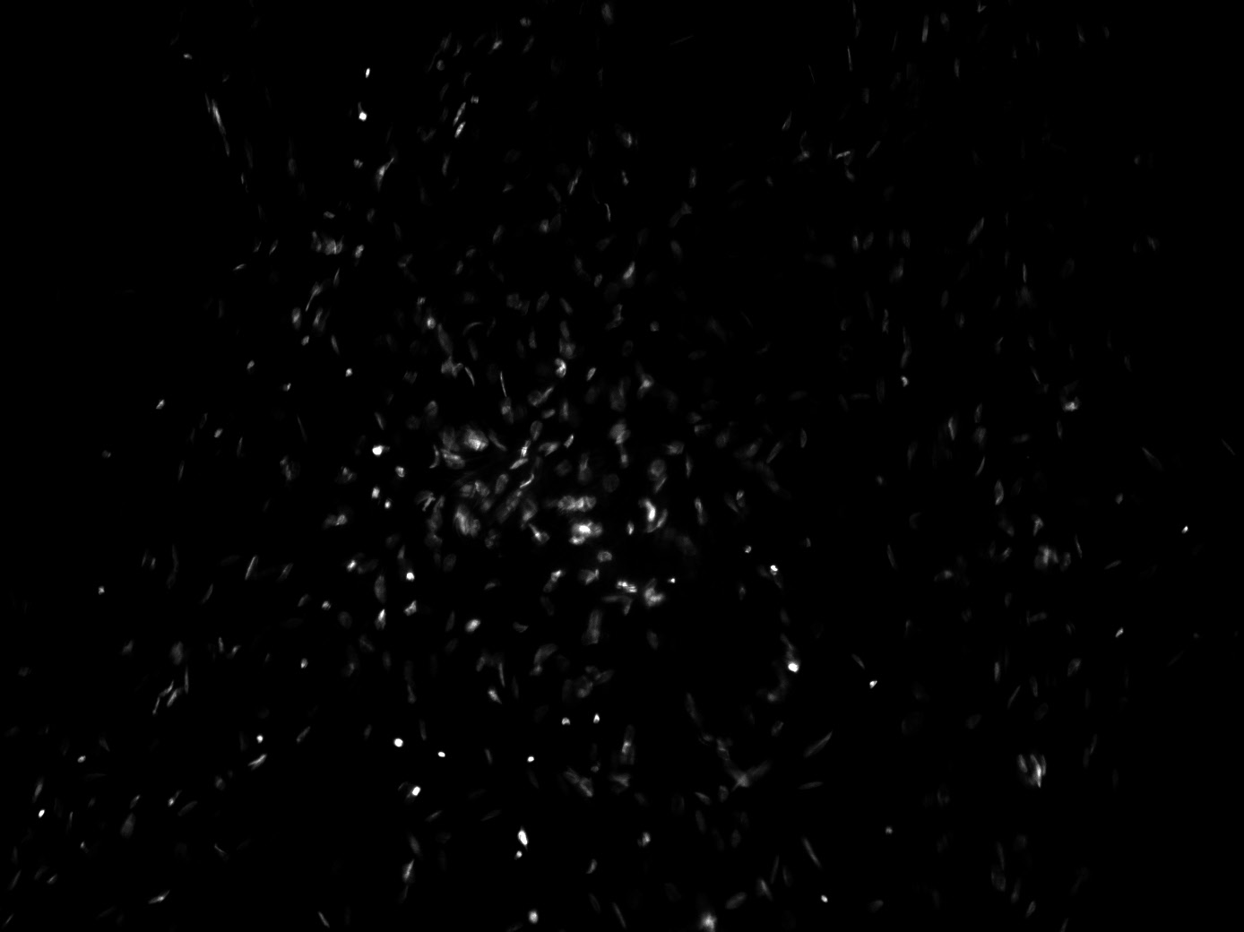

Figure 1. DAPI staining of a circular shape of cells from a smaller diameter hole.

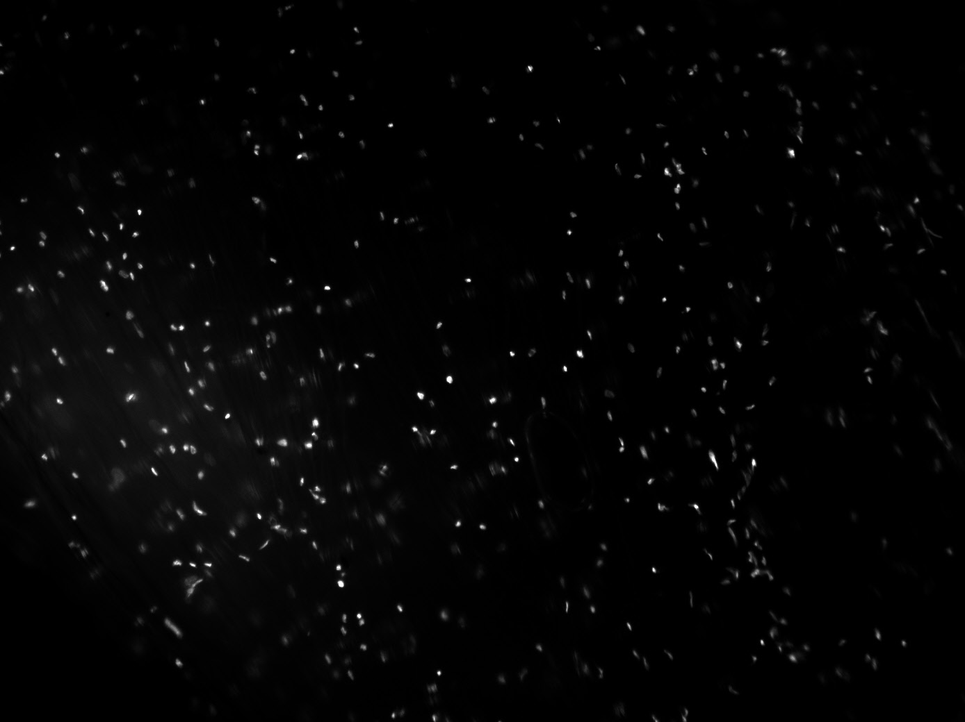

Figure 2. DAPI staining of an amorphous shape of cells from a larger diameter hole.

IV. DISCUSSION

This micropatterning technique seemed to work well in hindering cell growth in areas where the PDMS was bonded to the coverslip. The diameter of the holes in the device did not seem to affect the amount of cell growth present; however, the smaller diameter holes produced more rounded clusters. This is likely because the cells in the smaller holes proliferated and reached the edges of the PDMS before those in the larger holes did. Following this hypothesis, one could predict that had the cells been able to grow to confluency, circular clusters would have been more defined in both sets of holes.

V. CONCLUSION

Using a PDMS sheet over a coverslip is a simple yet effective way to achieve micropatterning without the use of stamps or photolithography. In addition, DAPI staining was successfully demonstrated as a way to verify the shapes of cell clusters from micropatterning.

REFERENCES

[1] Thery, M. (2010). Micropatterning as a tool to decipher cell morphogenesis and functions. Journal of Cell Science, 123(24), 4201-4213. doi: 10.1242/jcs.075150

[2] NanoInk. (2012). Single cell micropatterning. Retrieved from <http://www.nanoink.net/pdf/ApplicationNotes/AppNote_SingleCellMicropatterning_Final.pdf>

*I have neither given nor received any unauthorized aid in completing this work, nor have I presented someone else’s work as my own.*

