Fabrication, seeding, and testing of a cell perfusion microdevice

Emily Boggs, Lawrence Technological University

3 April 2013

***Abstract* – A cell seeding/perfusion device was fabricated from a SU-8 silicone master wafer and cast into PDMS bonded to a glass slide. After testing for proper fluid flow and leakage, the device was perfused with media and cells for seeding. Five days after seeding, the device was checked for cell proliferation using light microscopy and Live/Dead staining. Light microscopy showed significant cell growth which was confirmed by Live/Dead analysis. However, Live/Dead analysis did show an abundance of dead cells. Possible explanations for the lack of cell viability as shown by Live/Dead staining include cell death during perfusion with staining reagent or inadequate access to nutrients in the microdevice.**

***Index Terms*** **– microdevice, MEMS device, cell seeding, Live/Dead staining, fluorescent microscope.**

I. INTRODUCTION

The unique attributes of microdevices used for cell culturing come from their small size. Theoretically, all cells adherent on the device should have excellent access to oxygen and nutrients given the microscale thickness of the media layer. Smaller groups of cells can be studied and the extracellular environment can be more strictly controlled. This is particularly applicable to stem cell differentiation research, where the presence and concentration of differentiation signaling factors can be precisely modified [1].

However, progress in microdevice cell culture research has been obstructed by the difficult translation of macroscale physics, particularly fluid mechanics, to microscale environments [2]. Surface tension forces become stronger than gravity making air blockages and bubbles severe obstructions. Bubbles in particular, when burst in the confines of a microdevice, can rupture cell walls [2].

If these challenges could be overcome and cell culture techniques for microdevices optimized, these devices could quickly become commercial diagnostic tools. The advantages of using microfluidic devices for biological or chemical tests include the need for fewer reagents and fast reaction response time, as per smaller diffusion distances [2]. These advantages would also apply to cell culture-based testing. With increasing interest into “lab-on-a-chip” design and fabrication, cell culture could easily be integrated into devices for fast and accurate pathology tests.

II. EXPERIMENT

The device was previously fabricated from an SU-8 master wafer. PDMS mixed with a crosslinking agent was poured over the SU-8 features of wafer. After hardening, the PDMS mold was bonded to a glass slide. The device features a single inlet and single output port and two large rectangular chambers for cell growth (Figure 1).

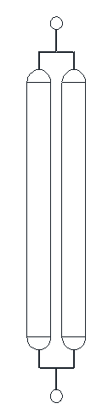

Figure 1. Microfluidics design for the cell seeding/perfusion device.

Immediately after fabrication, the device was tested for leaks and blockages by having water from a syringe attached to the inlet port tubing pushed through it; none were observed. The next steps involved preparing the device for receiving cells. First, the device was sterilized by perfusing ethanol through it and subsequently incubated for several hours. Next, the ethanol, which is cytotoxic to cells, was flushed out with an extended perfusion of PBS. Finally, just enough sterile media was perfused through the device to displace the PBS.

The cells used for seeding the device were human periodontal ligament fibroblasts (HPDLFs). The cells had begun culture in a 35 mm dish several days prior until confluency. The cells were lifted with 300 µL of trypsin and spun down in the Eppendorf Centrifuge 5415R for counting. The plate used for this experiment contained approximately 97500 cells.

The cells were resuspended in media and gently perfused into the device. During this procedure, the device was monitored under a light microscope to ensure the movement of cells into the cell growth chambers. Once the chambers reached a uniform cell density, the syringe of cell suspension was replaced with one containing only sterile media; the outlet port tubing was sealed shut with an Eppendorf tube. The device was then incubated at 37 °C for five days.

After incubation, the cell density in the device was first checked using a light microscope. To check the viability of these cells, a Live/Dead staining solution was perfused through the device after the cells had been rinsed with PBS. The device was incubated for an additional 20 minutes at 37 °C, and then the stains were visualized using fluorescent microscopy.

III. RESULTS

Initial light microscopy visualization of the cells in the device showed approximately 40% confluency. The cells exhibited the normal long, spindle shape of healthy, attached fibroblasts.

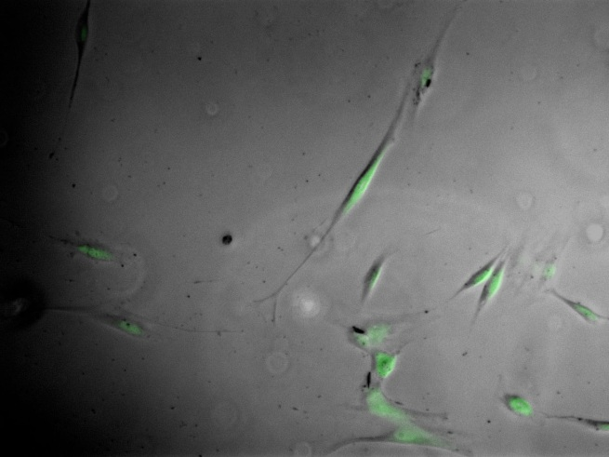

Figure 2. An in-phase microphotograph of the cells within the device overlaid with the green fluorescence of the calcein live stain.

However, Live/Dead analysis provided a different picture. The perfusions of media, PBS and staining solution had displaced many cells, causing them to clump near the outlet side of the growth chambers. The cells that did survive, though few, again showed the characteristic spindle shape of those observed under the light microscope (Figure 2).

IV. DISCUSSION

Despite a culture period of five days, the cells failed to grow over half the area of the device; in a conventional P100 petri dish, cell growth would be near 80% confluency. This result points to perhaps a deficiency in access to oxygen nutrients from the media. However, cells that did survive showed morphology particular to healthy fibroblasts. Most of these cells were in the cluster near the outlet channel.

No regularity existed to the speed at which the device was perfused with PBS and media. Exceptionally high shear stresses may have either ruptured cells or lifted them off the surface of the device. Having to continually re-adhere may have hindered the development of healthy morphology in some cells. Testing should be done to find an optimal pressure at which media could be perfused through the device. In addition, the syringe used to perfuse fluid in this experiment could be replaced by a mechanical device (like a syringe pump) that can perfuse at a consistent and constant rate.

V. CONCLUSION

Cell growth occurred within the microdevice, but not at a level comparable to macroscale cell culture. While many cells remained viable, in the device, a large proportion died. It is likely that high shear stresses related to perfusion and/or limited access to nutrients or oxygen hindered cell growth.

References

[1] Blagovic, K., Kim, L. Y., & Voldman, J. (2011). Microfluidic perfusion for regulating diffudible signaling in stem cells. PLoS ONE, 6(8), doi: 10.1371/ journal.pone.0022892

[2] Young, E. W. K., & Beebe, D. J. (2010). Fundamentals of microfluidic cell culture in controlled microenvironments. Chemical Society Reviews, 39(3), 1036-1048. doi: 10.1039/B909900J

*I have neither given nor received any unauthorized aid in completing this work, nor have I presented someone else’s work as my own.*

