Salt leaching and gas foaming for chitosan-based scaffold production

Emily Boggs

Biomedical Engineering Program, Lawrence Technological University, MI 48075

Abstract: Two types of chitosan mixtures were used to make scaffolds: one with sodium chloride (NaCl) and one with ammonium bicarbonate (NH₄HCO₃). The two scaffolds were formed into pellets and incubated. However, due to prolonged incubation many of the pellets burned and cracked. The chitosan/NaCl pellet was put in a beaker to leach out the NaCl; the chitosan/NH₄HCO₃ pellet underwent gas foaming to sublime away the ammonium bicarbonate. The NaCl leaching was incomplete but yielded craggy, elongated pores. The gas foaming worked well and left behind a chitosan scaffold with smooth and uniformly distributed pores.

Keywords: chitosan, sodium chloride, ammonium bicarbonate, salt leaching, gas foaming, scaffold

- Introduction
The purpose of this lab was to create two scaffolds with appropriate pore size, density, and distribution using chitosan. Chitosan is a derivative of the natural polysaccharide chitin, which is found in the shells of crustaceans, the exoskeletons of insects, and the cell walls of fungi. Its role in tissue engineering mirrors that of natural function: to provide a sturdy and protective framework for cells. In addition to its excellent biocompatibility, chitosan is also greatly favored for tissue engineering scaffolds due to its high degree of customization – its microstructure, crystallinity, and mechanical strength can all be tailored by changing the starting conditions of the chitosan [1].
In this experiment, chitosan powder was mixed with two different substrates, sodium chloride (NaCl) and ammonium bicarbonate (NH₄HCO₃). The two mixtures were then subjected to two different methods of removing the substrate, salt leaching and gas foaming, leaving behind pores. According to SEM characterization, the two mixtures and the two procedures yielded greatly different chitosan scaffolds, even though the same chitosan powder was used for each.

- Materials and Methods
  - Materials
- Chitosan (medium molecular weight) from Sigma Aldrich
- NaCl (store-bought Morton Salt)
- Ammonium bicarbonate from Sigma Aldrich
- Top loading scale (Fisher Science Education, ALF 204)
- Pellet die (custom made)
- Hydraulic press (MTS-810 Material Test System, Model No. 250 KN)
- Incubator (Thermo Scientific Lindberg Blue M)
- Aluminum foil
- Distilled water
  - Scaffold fabrication
    - Pellet formation and incubation
The basis for each scaffold was two mixed powders, one of chitosan and NaCl and another of chitosan and ammonium bicarbonate. Each mixture was combined at a 1:1 mass ratio (0.5 g of chitosan and 0.5 g of either substrate). The mixtures were further ground into a finer powder using a mortar and pestle. Then, each scaffold was formed using a pellet-shaped mold and a hydraulic press. The weight applied to each scaffold was 1000 lbs. The pellets were then placed on lubricated aluminum foil and incubated at 200 °C for 1 hour.
    - Salt Leaching
After cooling, the chitosan/NaCl pellet was immersed in a beaker of distilled water for a week days to remove the NaCl particles.
    - Gas Foaming
After cooling, the chitosan/ammonium bicarbonate pellet was immersed in approximately 95 °C distilled water for 10 minutes. The high temperature caused the ammonium bicarbonate particles to sublimate.
  - Scaffold characterization/testing
The results of the salt leaching and gas foaming with respect to pore morphology were analyzed using the SEM. Parameters used for analysis included pore density, pore distribution, pore size and pore shape. Predictions were made as to whether the measured parameters would be conducive to cell growth and proliferation.

- Results and Discussion
  - Scaffold response to incubation and substrate removal procedures
The incubation of the scaffolds for one hour at 200 °C proved too extreme; many of the scaffolds, including most of the chitosan/NaCl composites, were found to be burned and fractured upon removal. However, this did not prove much of a problem for the scaffolds, and indeed added to their structural integrity when immersed in water.
The chitosan/NaCl scaffolds were supposed to be left in distilled water for a week but were removed sooner due to the fear that they would disintegrate completely. As a result, not all of the NaCl had been removed when the scaffolds were characterized.
The chitosan/ammonium bicarbonate scaffolds did better. Burned scaffolds cracked along their outer edges but remained intact for characterization.

  - Analysis of scaffold pore structure
SEM pictures and measurements courtesy of John Schoenbeck.

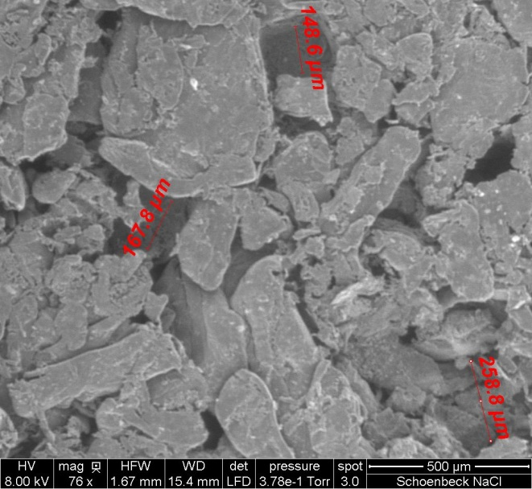
Figure 1: NaCl scaffold at mag 76x

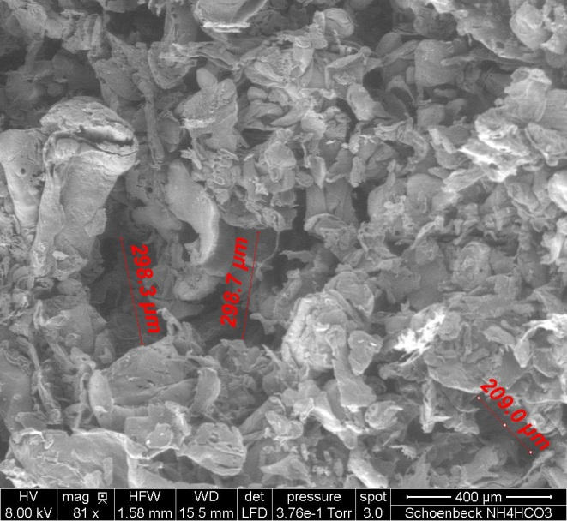
Figure 2: Ammonium bicarbonate scaffold at mag 81x
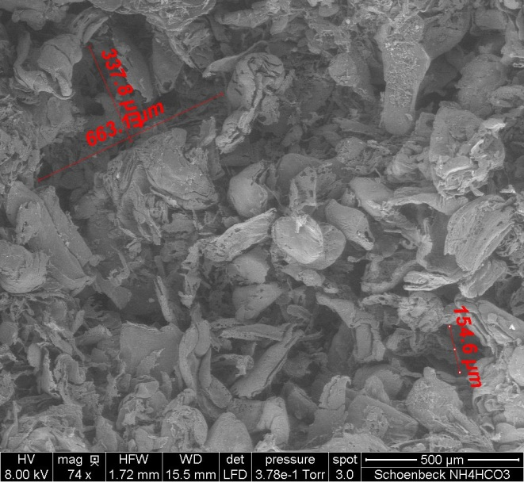
Figure 3: Ammonium bicarbonate scaffold at mag 74x

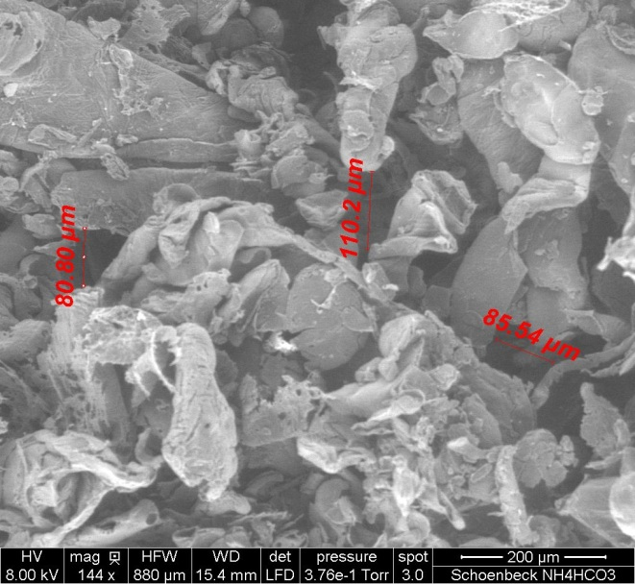
Figure 4: Ammonium bicarbonate scaffold at mag 144x

Under the SEM, the incompletely leached chitosan/NaCl scaffolds showed pores with irregular, jagged edges where the salt had dissolved away [Fig 1]. Only two pores were measured; one had a diameter of approximately 168 microns, while the other was 259 microns. Nearby pores showed diameters of around 125 to 225 microns, revealing the scaffold’s uniformity of pore size. The degree of interconnectedness is likely to be low, as the outside edge of the scaffold shows flattened structures stacked closely to one another, an arrangement unlikely to promote cell migration into the scaffold. White spots indicate the remnants of undissolved NaCl. The chitosan/ammonium bicarbonate scaffold showed rounder pores with diameters ranging from 150 to 660 microns with a relatively uniform density [Fig 2, 3]. At a closer magnification [Fig 4], pores ranging in size from 80 to 110 microns can be identified. Based on the scaffold structure visible on the surface of the SEM pictures, the pores are likely to have a large degree of interconnectedness, especially since some of the more elongated “pores” look more like channels.
  - Analyses of problems and suggested solutions
The greatest hurdle faced in this procedure was predicting a scaffold composition that would not dissolve completely when immersed in water. Both NaCl and ammonium bicarbonate are readily dissolved in water, but chitosan requires an acidic solution in order to dissolve [2]. By increasing the amount of chitosan in the mixture at the expense of the two substrates, a more stable structure could be produced. However, increasing the chitosan content of the scaffold would likely lead to a smaller pore density and size.
Another suggestion for strengthening the scaffolds is to apply a greater weight on them with the hydraulic press. However, the pellet mold would need to be redesigned to handle this amount of force.
A second problem encountered was the burning of the scaffolds in the incubator. The protocol originally called for incubation at 250 °C for 30 minutes instead of 200 °C for 1 hour; those conditions should be tested to see if they work. I also think some more general testing needs to be done with these scaffolds to find an appropriate temperature and incubation duration.

- Conclusion
Most cell types require approximately 10 to 50 micron-sized pores in which to grow in and migrate through [3]. Based solely on this criteria, both scaffolds would be suitable. However, based on the above analyses, the ammonium bicarbonate scaffold is likely to be more successful in encouraging cell proliferation and migration. As the two scaffolds stand in their present state, it would be impossible to even grow cells onto the surface of NaCl scaffold since the remaining salt particles would kill them. Even if the particles had all been dissolved away, the perceived low degree of interconnectedness between pores would likely hinder cell migration.
The chitosan content of the mixtures needs to be increased or the hydraulic pressure during pellet formation increased to create stronger scaffolds. An appropriate temperature and incubation period also needs to be found.

References
[1] Nettles DL, Elder SH, Gilbert JA. Potential Use of Chitosan as a Cell Scaffold Material for Cartilage Tissue Engineering. Tissue Engineering: Mary Ann Liebert, Inc 2002; 8:1009-1016.
[2] Lu S, Song X, Cao D, Chen, Y, Yao K. Preparation of Water-Soluble Chitosan. Journal of Applied Polymer Science: Wiley Periodicals 2004; 91:3497-3503.
[3] Bou-Akl, T. Powerpoint. In vivo synthesis of tissue and organs. September 24, 2012. Slide 21.

Appendix
Salt Leaching/Gas Foaming Protocol (see attachment)

I have neither given nor received any unauthorized aid in completing this work, nor have I presented someone else’s work as my own.

________________________________________

