Fabrication and Testing of Two Microfluidic Designs: A Concentration Gradient Generator and a Cell Seeding/Perfusion Device

Emily Boggs, Lawrence Technological University

13 February 2013

***Abstract –* Two microfluidics designs were fabricated and tested for efficacy. The first device tested was a concentration gradient generator; the second a cell seeding/perfusion device. Both were fabricated from a SU-8 silicone master wafer and cast into PDMS. The PDMS portion of the device was plasma-treated and bonded to a glass slide. Silicone tubing was introduced into the fluidic access ports and red dye was injected to look for leaks or blockages. Neither device showed signs of leakage but both had blockages. The concentration gradient device developed a blockage at the site of one of its outlet ports; the cell seeding/perfusion device showed significant blockage in the chambers reserved for cell growth. The former was likely due to a scratch or flaw in the SU-8 master mold; the latter due to excessive pressure during its bonding to the glass slide.**

***Index Terms* – Microfluidics, concentration gradient generator, cell-seeding microfluidics.**

I. Introduction

T

wo device designs were fabricated and tested. The first design was for a concentration gradient device. This device had two input fluidic ports and six output fluidic ports. Two solutions of different concentrations could each be introduced to the device through the two inlet ports. The design features long, winding, and progressively branching microchannels (Fig. 1) that separate the fluid into a step gradient. The gradient is formed based on the behavior of laminar flow at each of the intersections (or nodes): the fluid is split evenly into each branch, and each progressive branch (except those on the extreme left and right sides) receive fluid from two previous separate branches. The winding channels serve to lengthen the time the two fluids are in contact with each other, allowing for diffusion to equilibrate the concentration into one fluid, which is then split and combined with other fluids again [1]. This device should result in six discrete concentrations of solution arranged in a gradient with respect to the two solutions first injected into the system. In this device, each gradient “step” has its own outlet port.

Figure 1. A: Concentration gradient design by Dertinger et al. [1]. B: Schematic of concentration gradient device used in this procedure. Note the input ports (left) and output ports (right). C: A close up of one “branch” in the schematic from B. The length of the branch allows two fluids more time to reach concentration equilibrium.

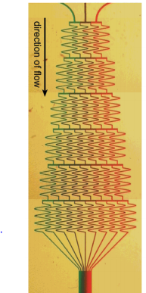

**A**

**B**



**C**

The applications of microfluidic concentration gradients mostly involve highly-controlled cell studies in which the response of cells to a certain concentration of chemical factors. In one study, Beta et al. [2] create a concentration gradient of chemotactic factors to study eukaryotic cell movement, specifically the changes that occur in the cytoskeleton. Only the concentration gradient created by a microfluidics device is precise and fast enough to accommodate such minute observations.

The second design was for a basic cell-seeding/perfusion device (Fig. 2). It consisted of two fluidic access ports for input and output and two wide chambers for cell growth connected in parallel. The conditions in this microenvironment can be tightly controlled, making it an excellent platform for stem cell study. Blagovic et al. [3] are using a similarly-designed (though much more complex) microfluidics device to study differentiation-signaling factors (Fig. 3). By continuously perfusing the cells with new media, factors secreted by some cells are swept away instead of being allowed to interact with nearby cells, as would occur in normal, static culture. This control allows for greater manipulation of the cells’ environment.



Figure 2. Microfluidics design for the cell seeding/perfusion device.

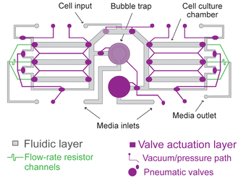

Figure 3. Cell perfusion via microfluidics design by Blagovich et. Al [3]. The setup of chambers on the left and right of the device closely resemble the two chambers present in the device used in this procedure.

II. Experiment

Fabrication of the devices began with an SU-8 master: a silicon wafer with SU-8 features built up from photolithography. The SU-8 features formed a negative of the device design so as to be a “mold” for creating the devices’ microchannels. PDMS mixed with a crosslinking agent was poured over the SU-8 master. The wafer and liquid polymer were then placed in a desiccator to remove air bubbles from the PDMS before being cured in an oven at 65 °C for 3-6 hours. After curing, the hardened PDMS was then cut and peeled away from the SU-8 master, yielding positive casts of the devices. Holes were then carefully punched for fluidic port access.

To complete the device, the PDMS cast was bonded to a glass slide. To facilitate binding, the slide and the PDMS were both treated with plasma before being pressed together. To secure the connection, the device was heated to 100 °C for ten minutes before testing.

Testing of the efficacy of the devices included ensuring that no leakages were present and that microchannels were conserved after binding. Small diameter silicone tubing was inserted into the fluidic access ports of both devices. A syringe filled with red dye was then connected to the tubes at the input ports. Injection of the dye allowed for the observation of the movement of fluid through the device, indicating the presence of any leaks or blockages. Leakages could be caused by either an insufficient bonding between PDMS and glass or trapped air bubbles, allowing for the movement of fluid between channels or an escape of fluid from the device at the PDMS-glass interface. Blockages could be caused by damage to the SU-8 master features before curing or adhesion of dust particles to the PDMS-glass interface before bonding. The presence of a blockage could be signified by a resistance to injection of the red dye within the microchannels or observed by a lack of dye in certain branches or tubes in the device.

III. Results

The first device tested was the concentration gradient generator. Red dye was injected into one of the two inlet ports. Observations included that the channels on the same side as the injection site filled first, regardless of how close to the outlet ports they were. Dye also travelled sideways, although at a slower rate, and eventually filled the other inlet port, as no fluid pressure was applied there. A subsequent test with water pushing out the dye was performed using the other inlet, and fluid movement consistent with the first test. No leakages were found; however, one of the outlet ports was blocked, as the inserted silicone tube remained empty. Closer examination at 3X magnification revealed that the blockage was located at the boundary between the circle delineating the outlet port and the microchannel leading to it; no amount of fluid pressure could move the dye past the boundary into the port (Fig. 3).

The second device tested was the cell-seeded microchannel. Like with the first device, red dye was injected into a port. However, the dye only travelled along the peripheries of the two large channels, failing to reach the center areas (Fig 4). The dye did still reach the outlet port with minimum fluid resistance.

IV. Discussion

Both devices performed well in the sense that a continuous flow from inlet(s) to outlet(s) was achieved. The concentration gradient device showed positive results up to one of the six outlet ports, where no dye was seen filling the port or the silicon tube. Since the dye stopped at the boundary between the port and the microchannel, it can be inferred that the blockage was likely caused by an irregularity at this intersection of edges and not by a random particle from the air (Fig. 5). Since others who tested the same device experienced no such problems at this exact site, the irregularity is not from an error in the original design. However, since each of these same PDMS casts were taken from separate SU-8 molds on the same wafer, it is most likely that the irregularity originated from a scratch or other defect on that particular SU-8 mold. This defect was then picked up by the PDMS cast poured over it. This would explain why the other devices were not affected.

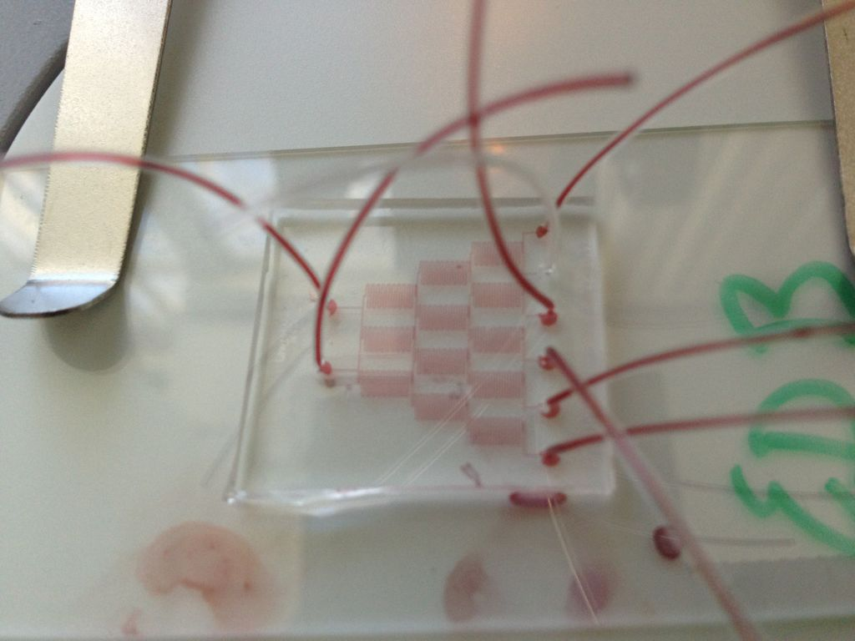 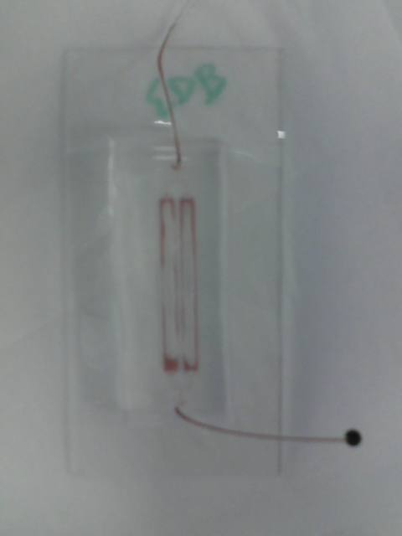

Figure 3 (above). The concentration gradient device after injection of red dye into the upper inlet port. Note the lack of dye in the silicone tube of the second from top outlet port.

Figure 4 (left). The cell-seeding/perfusion device after injection with red dye into the inlet port (top). Note the lack of dye in the center of the chambers; note also the successful flow of fluid from inlet to outlet port.



Figure 5. A closer view of the blocked output port of the concentration gradient device.

Fluidic access port

Silicone tubing

Site of blockage

For the cell-seeded microchannel device, though the dye managed to create a continuous flow from inlet to outlet ports, the centers of each of the two channels were not perfused with fluid (Fig. 4). This flaw would likely make the device inoperative. First, cells introduced into the device via fluid through the input port would only have contact with the peripheries of the channels. Second, even if cells *did* attach throughout the center of the channels, no media could be delivered to them. These large blockages were likely caused by the center of the channels accidently bonding to the glass after plasma treatment. If this is the case, then extreme care must be taken in subsequent fabrications of this device to preserve the two main perfusion channels.

V. Conclusion

Not all bioMEMS devices have to be complicated or have moving parts. The microfluidic device designs fabricated and tested in this experiment show great promise in the field of cell behavior research. Though both devices were fabricated with blockages, both exhibited a continuous flow of fluid from inlet(s) to outlet(s). The problem presented by the blockages can easy be remedied in subsequent fabrications if more care is taken during the procedure.

References

[1] Dertinger, S. K. W., Chiu, D. T., Jeon, N. L., & Whitesides, G. M. (2001). Generation of gradients having complex shapes using microfluidic networks.*Analytical Chemistry*, *73*, 1240-1246. Retrieved from http://gmwgroup.harvard.edu/pubs/pdf/733.pdf

[2] Beta, C., & Bodenschatz, E. (2011). Microfluidic tools for quantitative studies of eukaryotic chemotaxis. European Journal of Cell Biology, 90, 811-816. doi: 10.1016/j.ejcb.2011.05.006

[3] Blagovic, K., Kim, L. Y., & Voldman, J. (2011). Microfluidic perfusion for regulating diffudible signaling in stem cells. PLoS ONE, 6(8), doi: 10.1371/ journal.pone.0022892

*I have neither given nor received any unauthorized aid in completing this work, nor have I presented someone else’s work as my own.*

